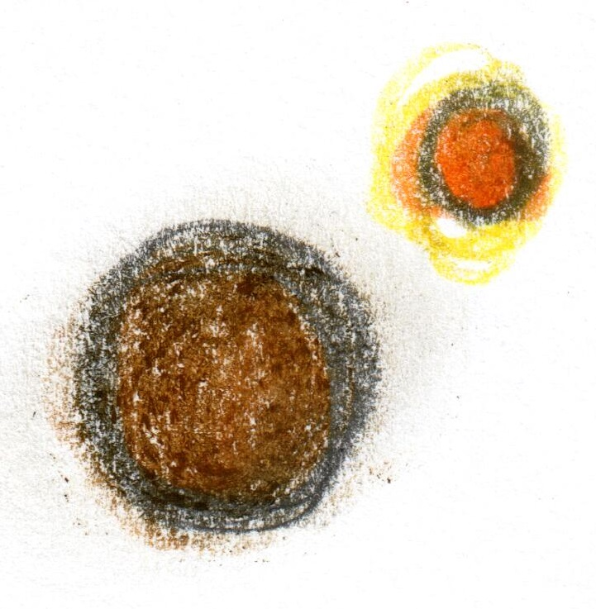

**Introduction**

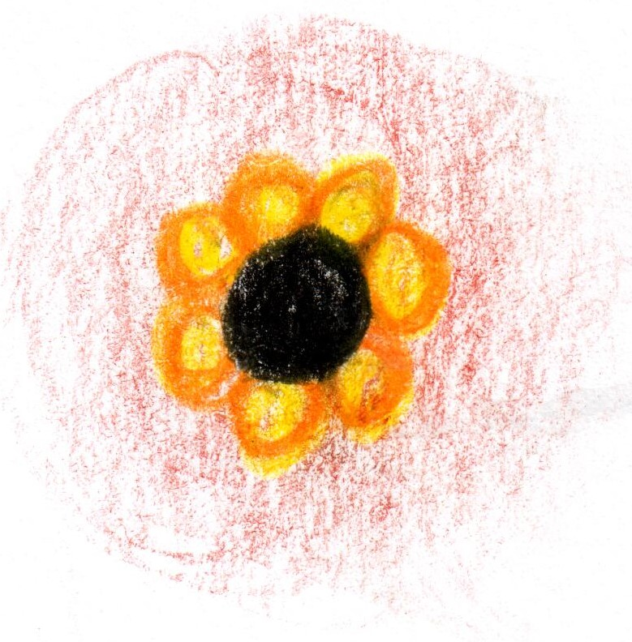

**Smoked Eel**

**apple / turnip**



**Scallop**

**tomato / rose**

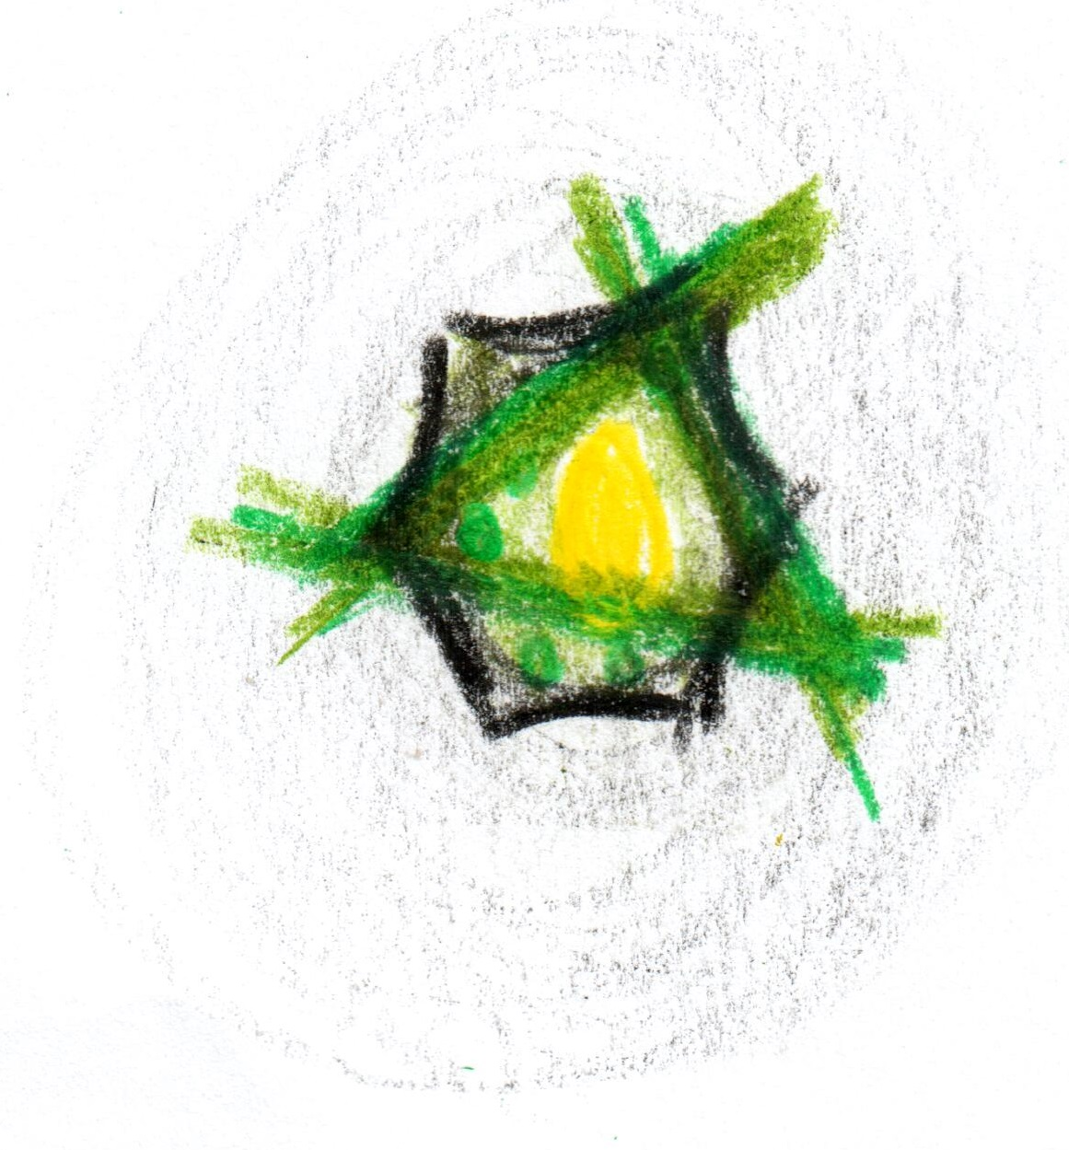

**Sea Leek**

**charcoal / horseradish**

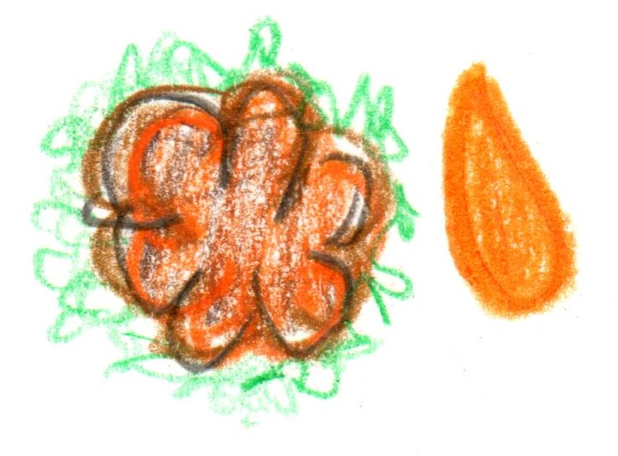

**Veal sweetbread**

**miso / coleslaw**

**Sauce robert**

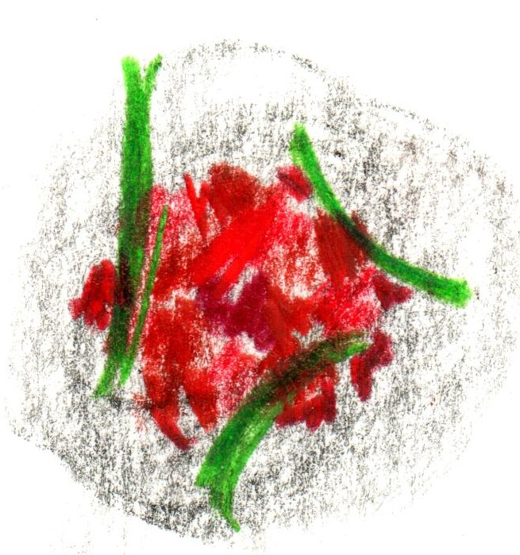

**Cornish Tuna**

**“tart-tare”**

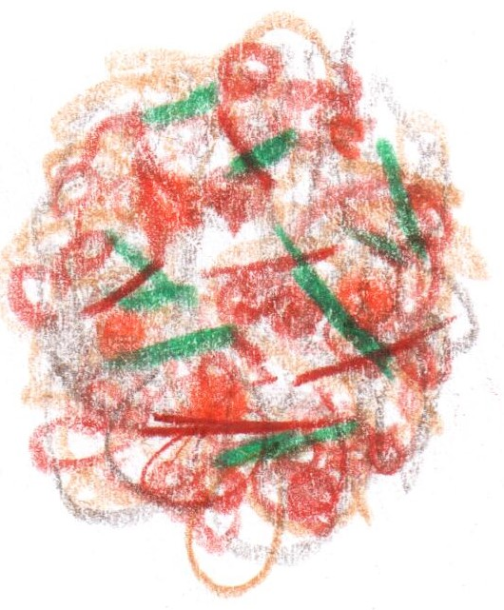

**Muesli**

**from the RSB Archive**

**Conclusion**

**‘Pelargonium’**



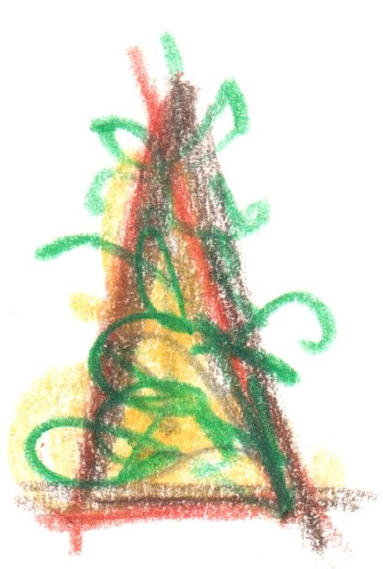

**From the Garden**

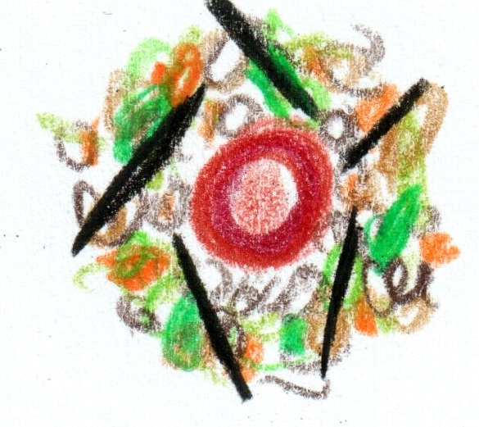

**St Brides Duck**

**Cassoulet**

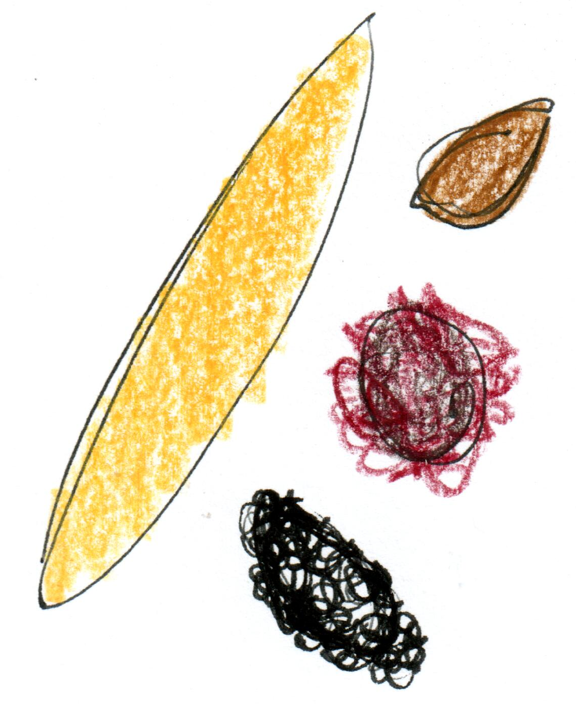

**Cornish Turbot**

**mushroom / chicory**

**caviar**

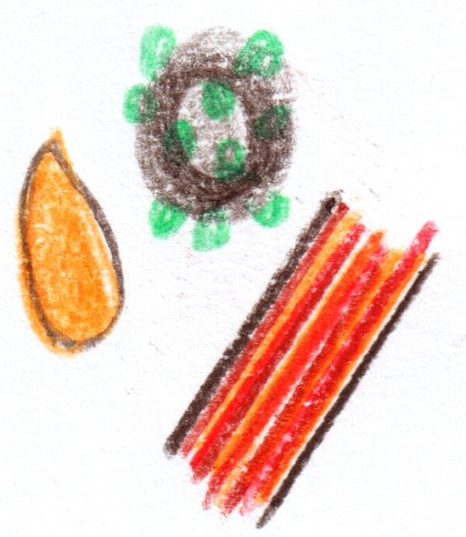

**Wagyu Beef**

**‘au poivre’**

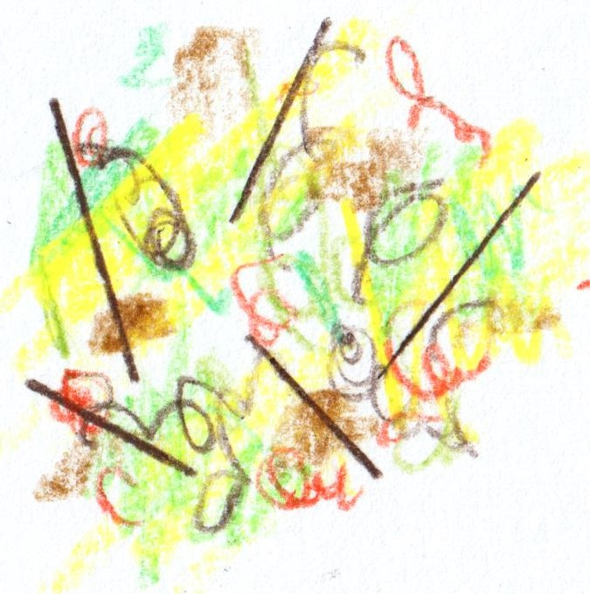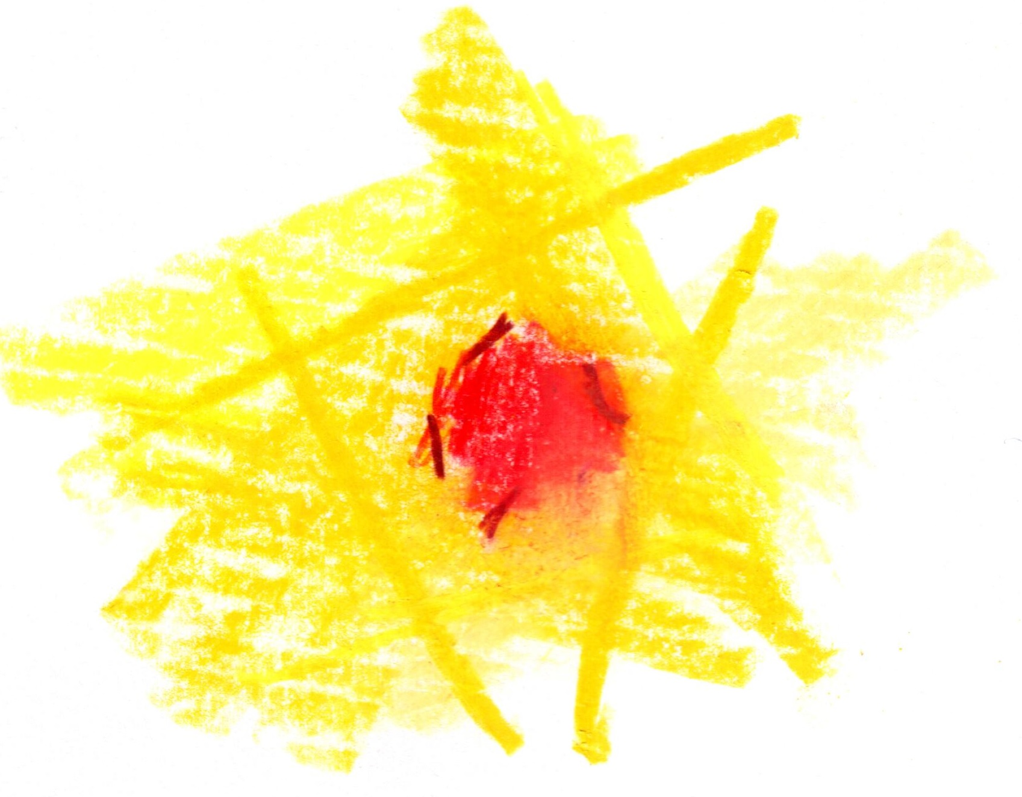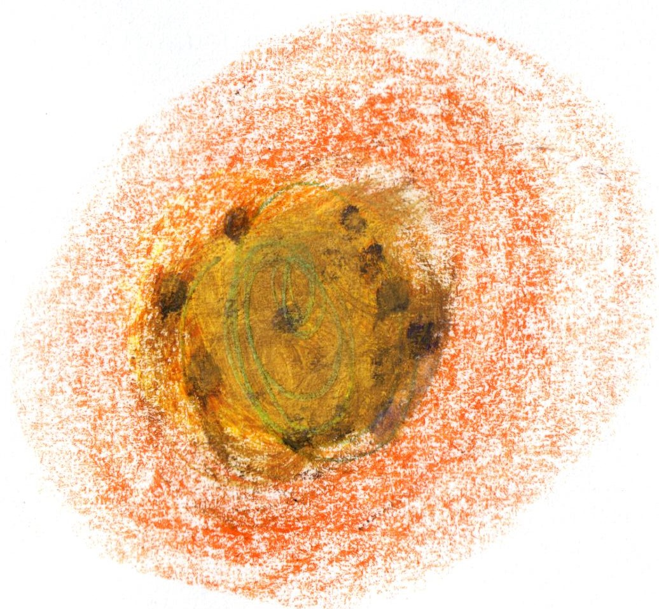

**White Chocolate**

**yuzu / pine**

**‘The crossover’**

**Rhubarb**

**hibiscus / milk**

**Conclusion**

**Fifteen Courses**

**£279**