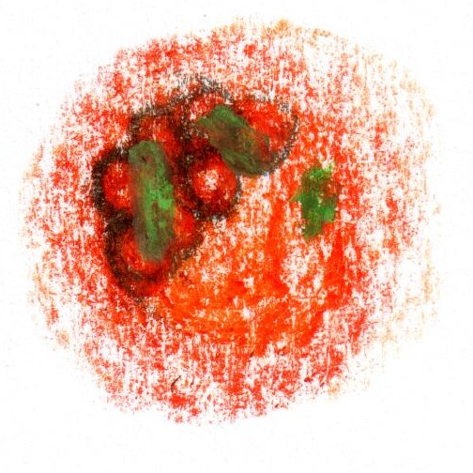

**Introduction**

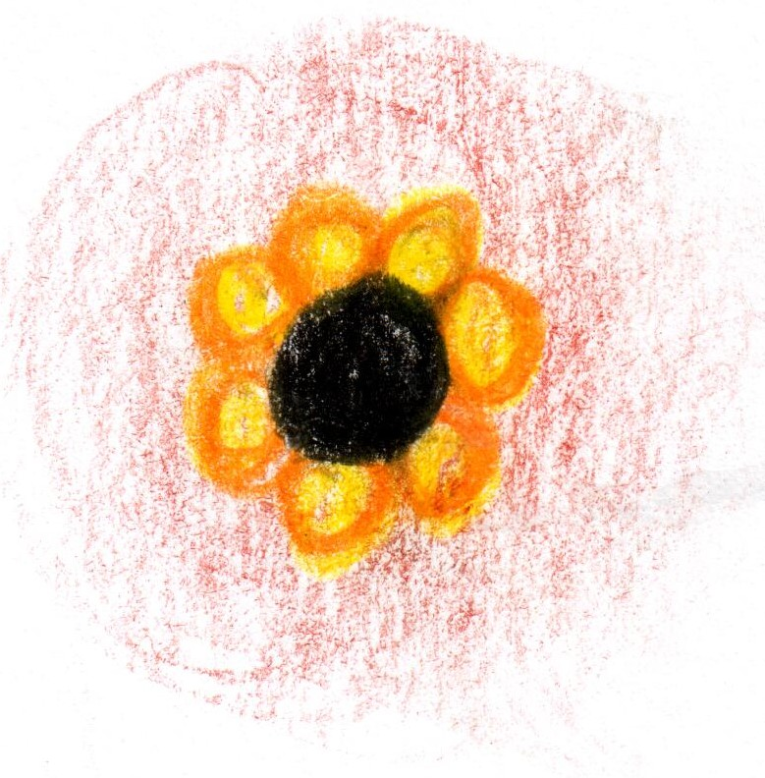

**Smoked Eel**

**apple / turnip**

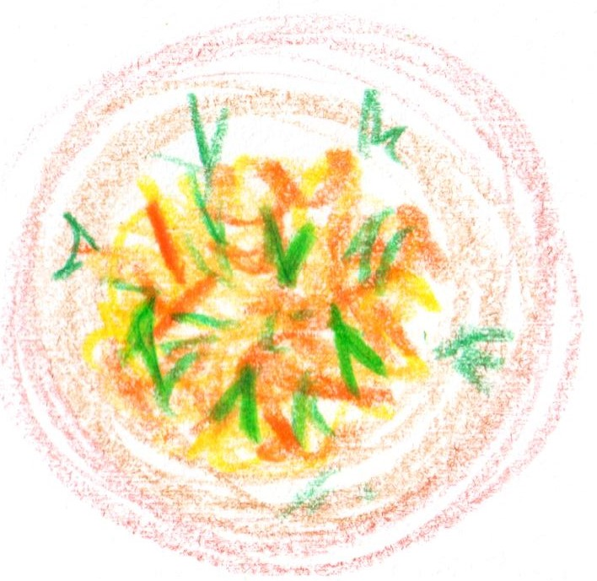

**Crab**

**peanut brittle**

**bisque**

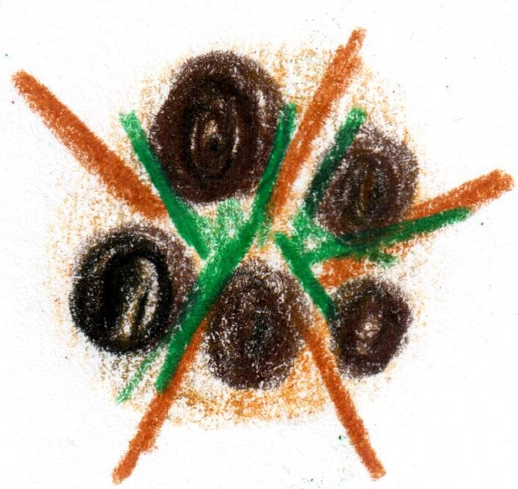

**From the Embers**

**potato / hazelnut**

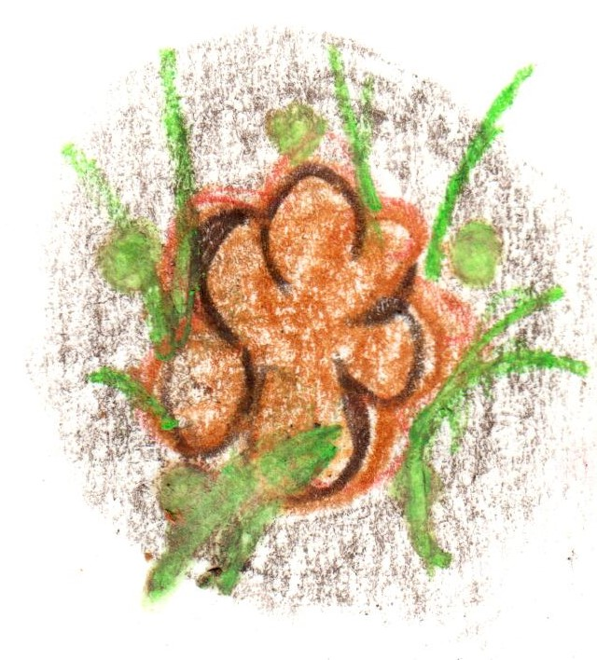

**Veal sweetbread**

**lentil / lime**

**indian spices**

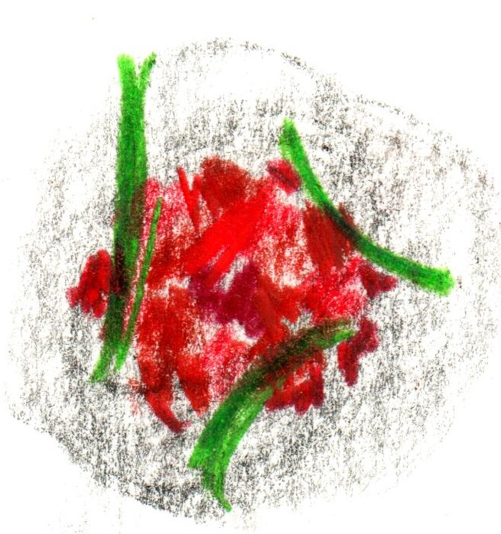

**Cornish Tuna**

**beetroot / ponzu**

**fennel**

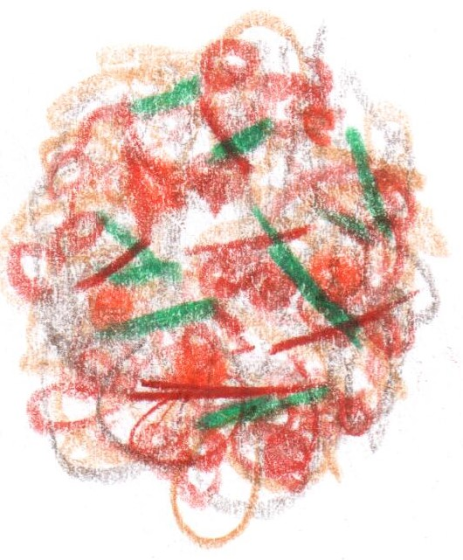

**Duck Liver Muesli**

**from the RSB Archive**

**Conclusion**

**‘Pelargonium’**

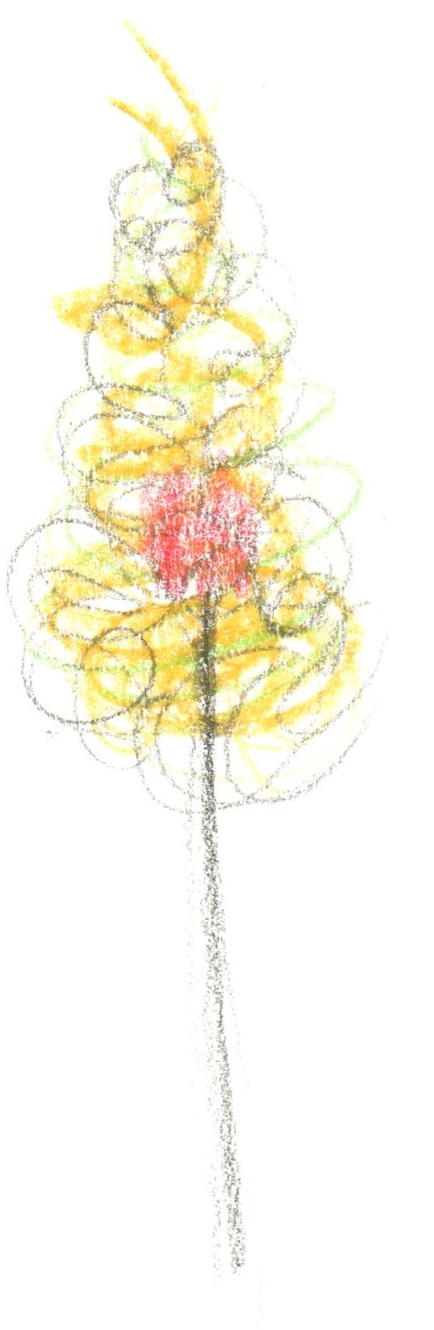

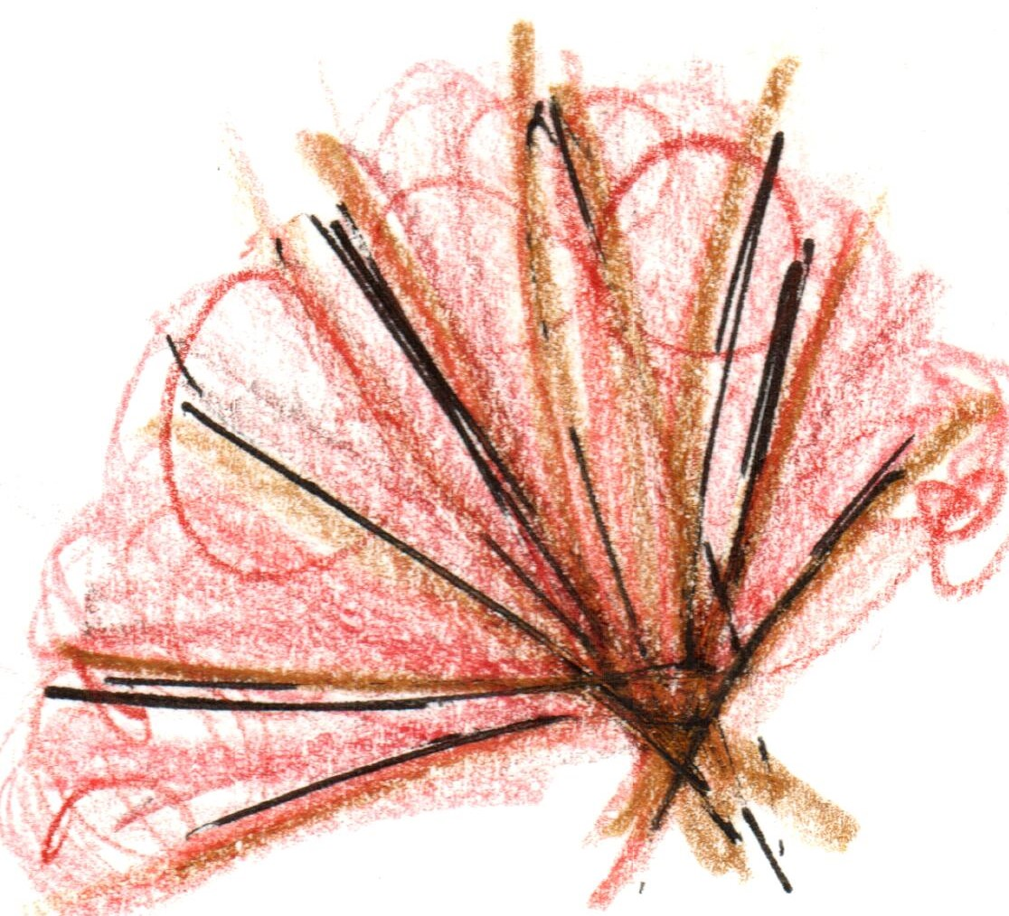

**Brown Hare**

**“Part 1”**

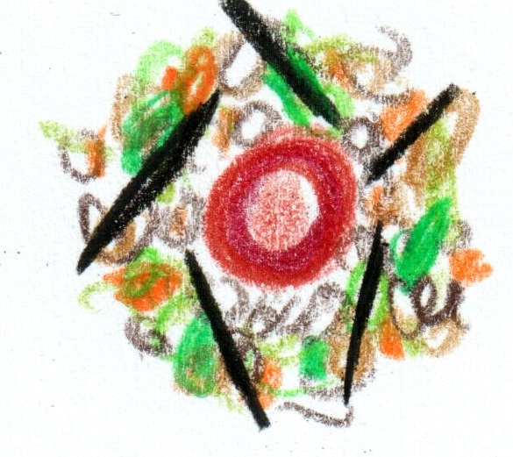

**Brown Hare**

**“part 2”**

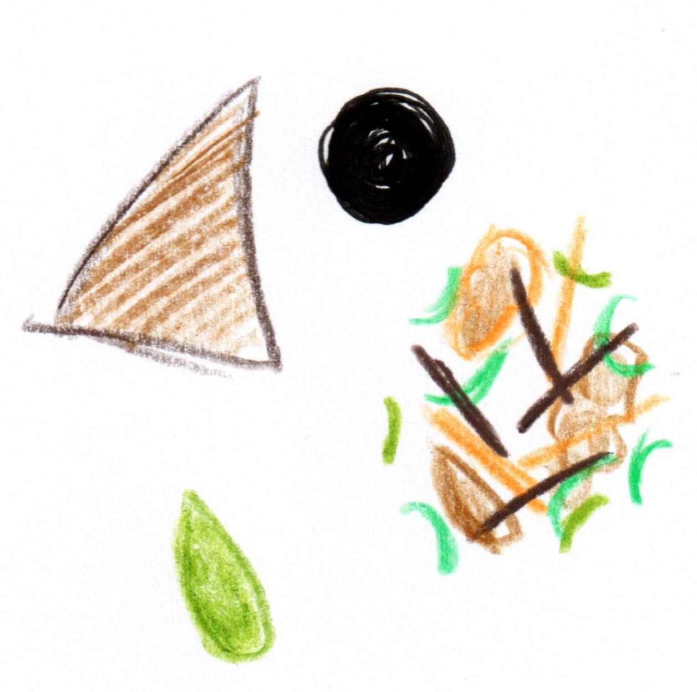

**Roast Turbot**

**tuber / roots**

**Truffled sauce nero**

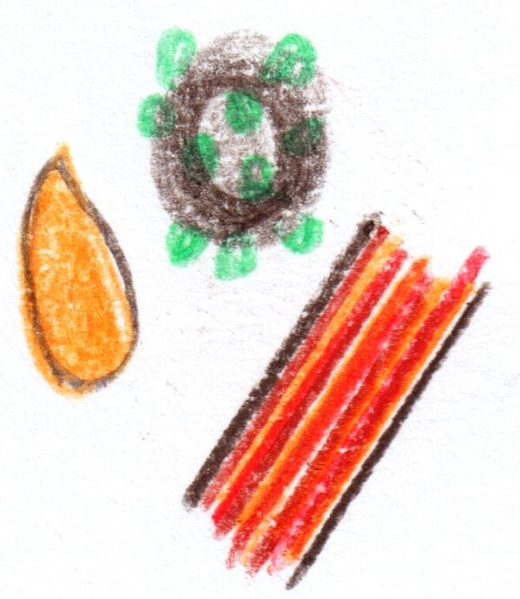

**Wagyu Beef**

**‘au poivre’**

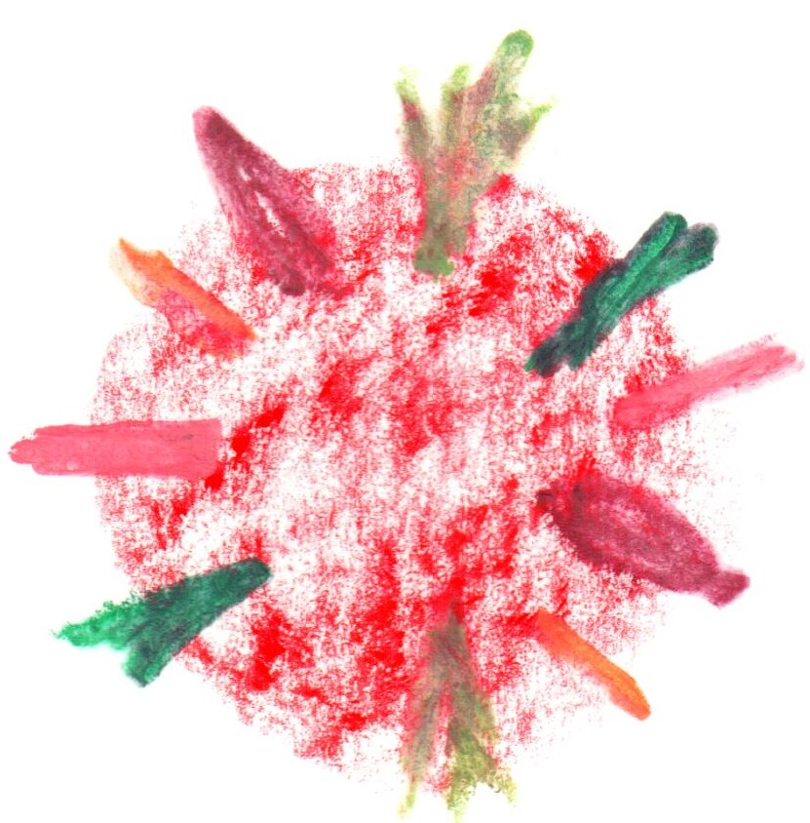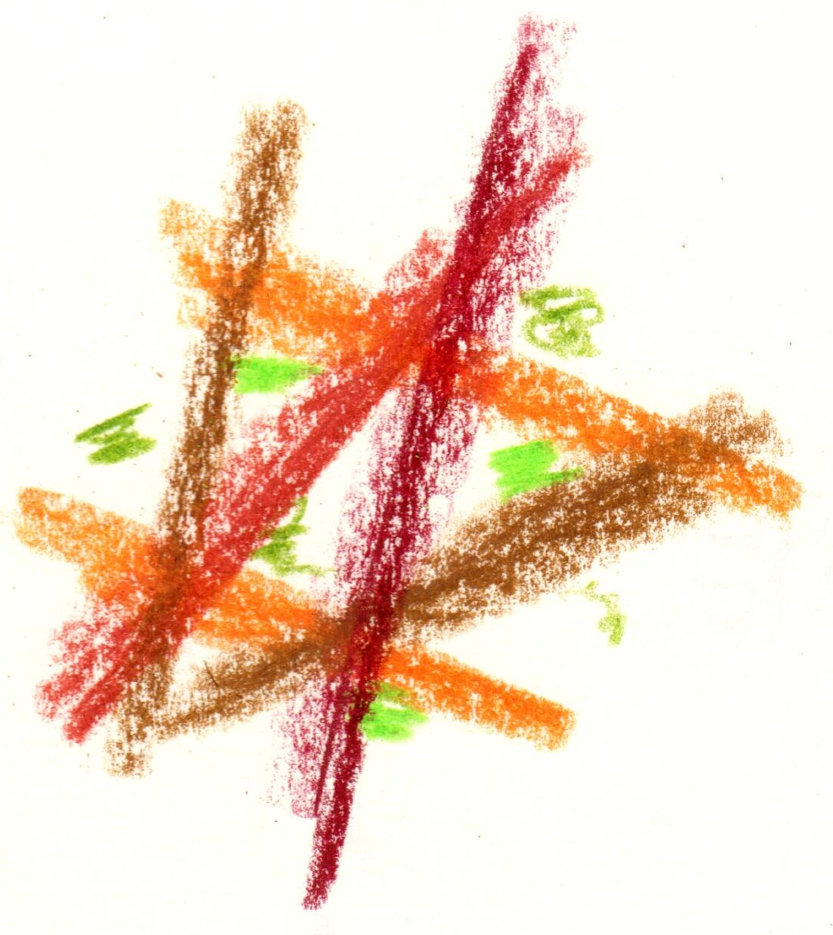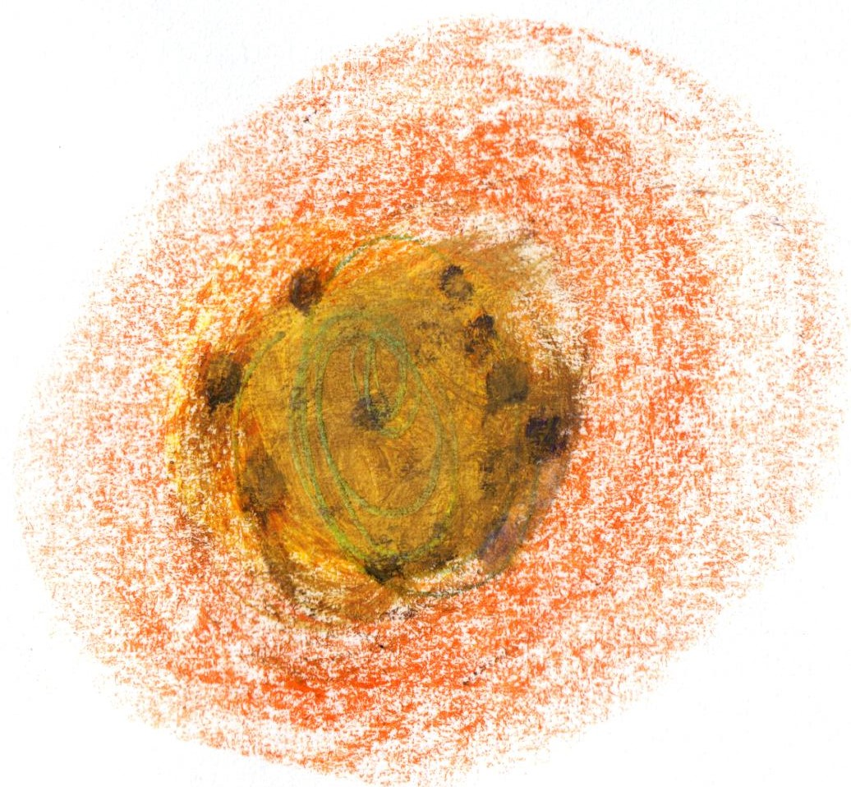

**Savarin**

**‘RSB Cuvee’**

**plum / rose**

**Conclusion**

**Sherwood Forest**

**’Autumn’**

**Fifteen Courses**

**£279**

**‘The crossover’**