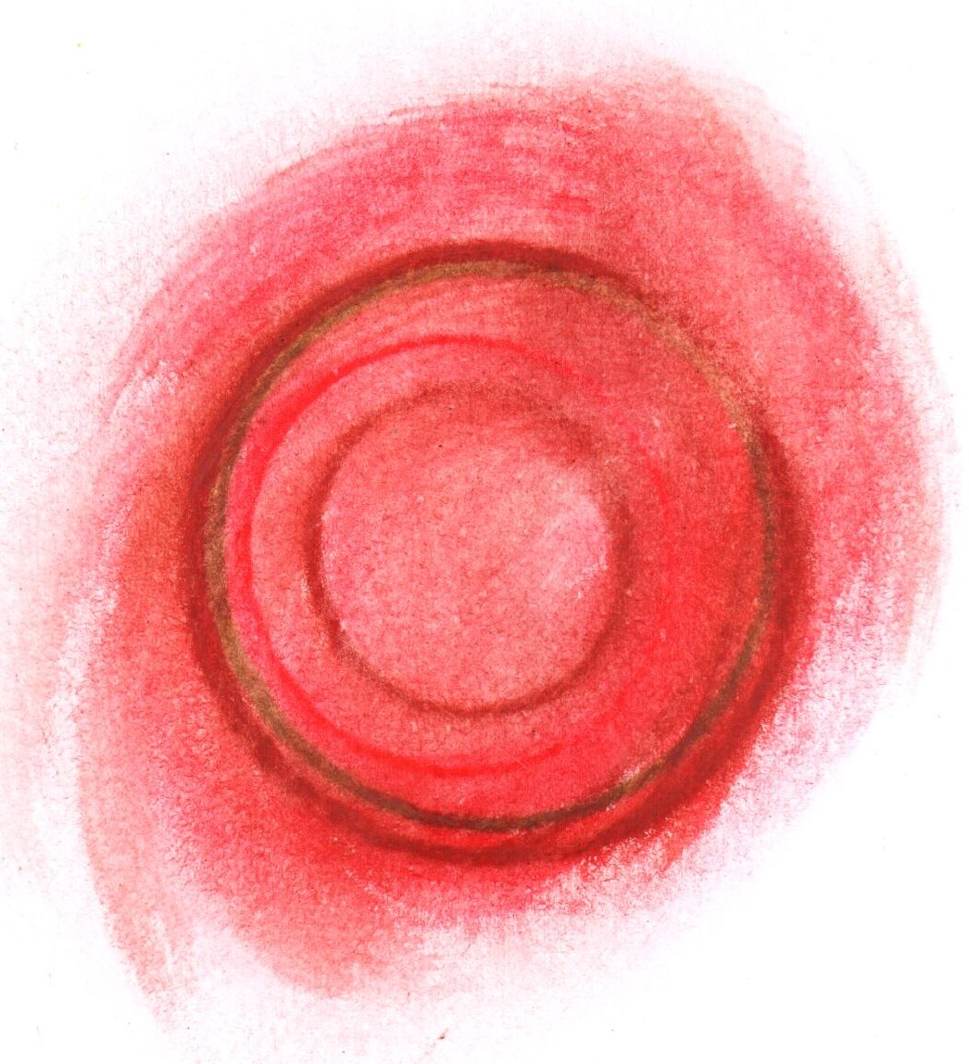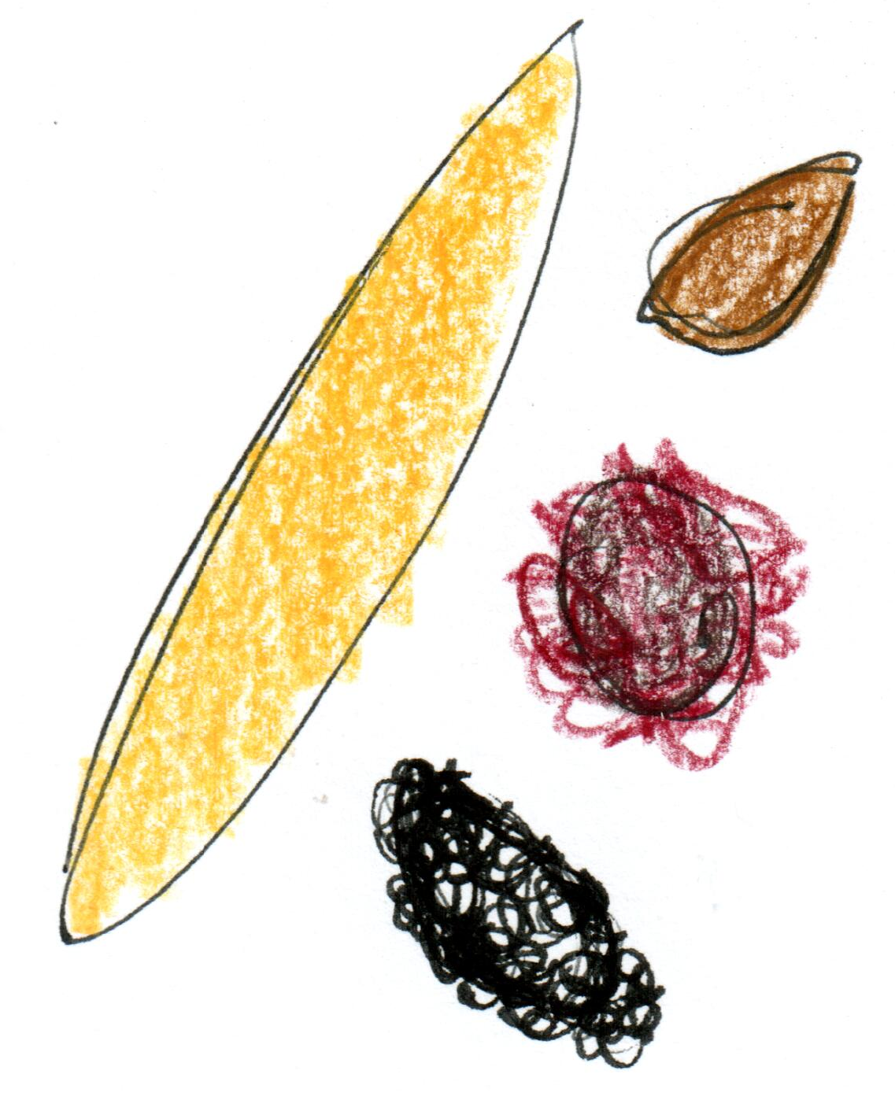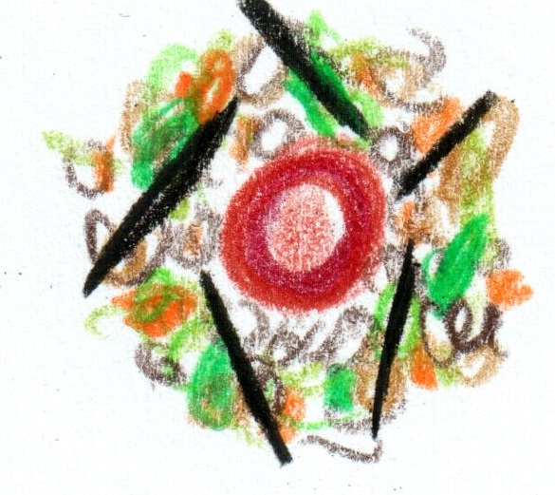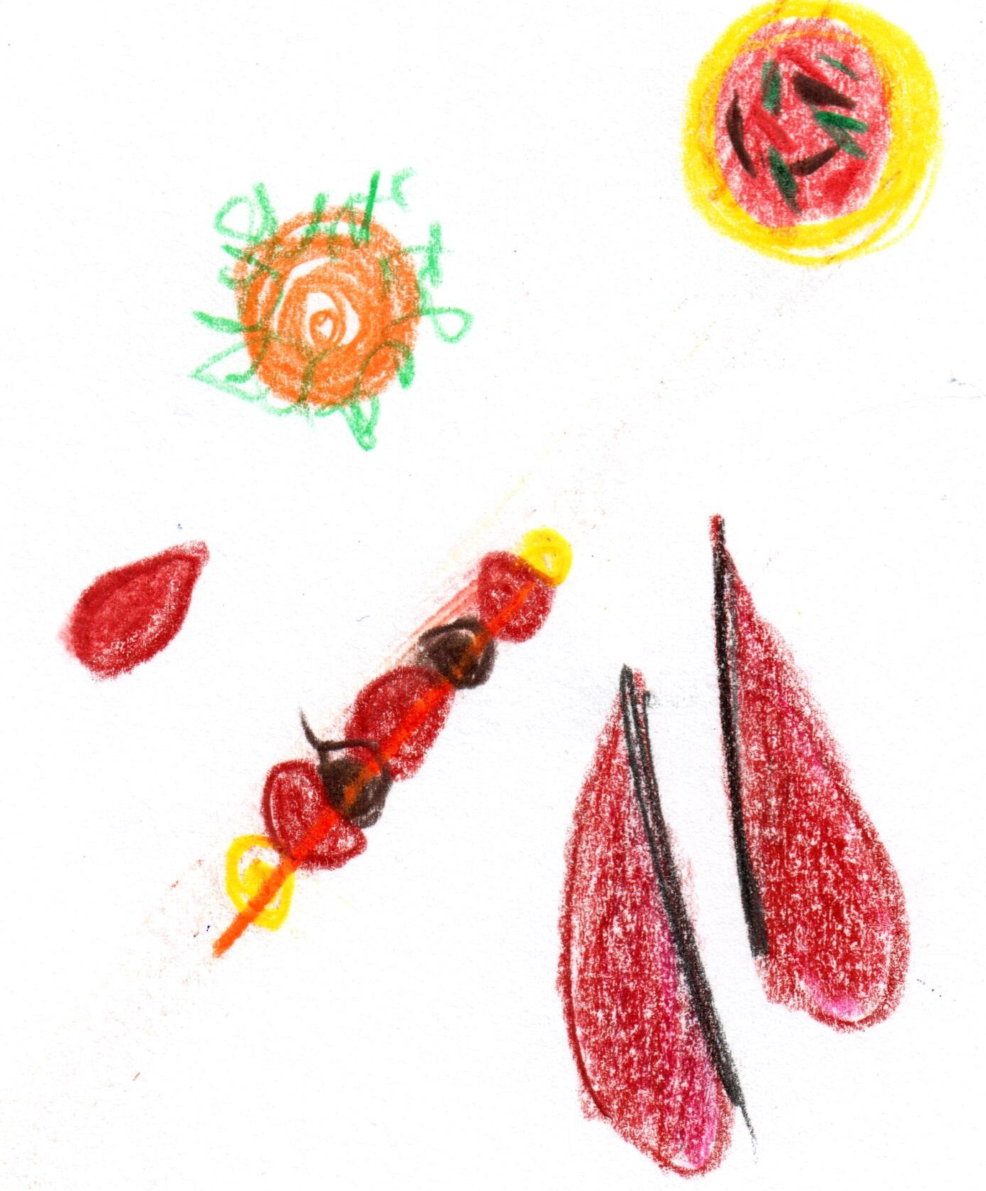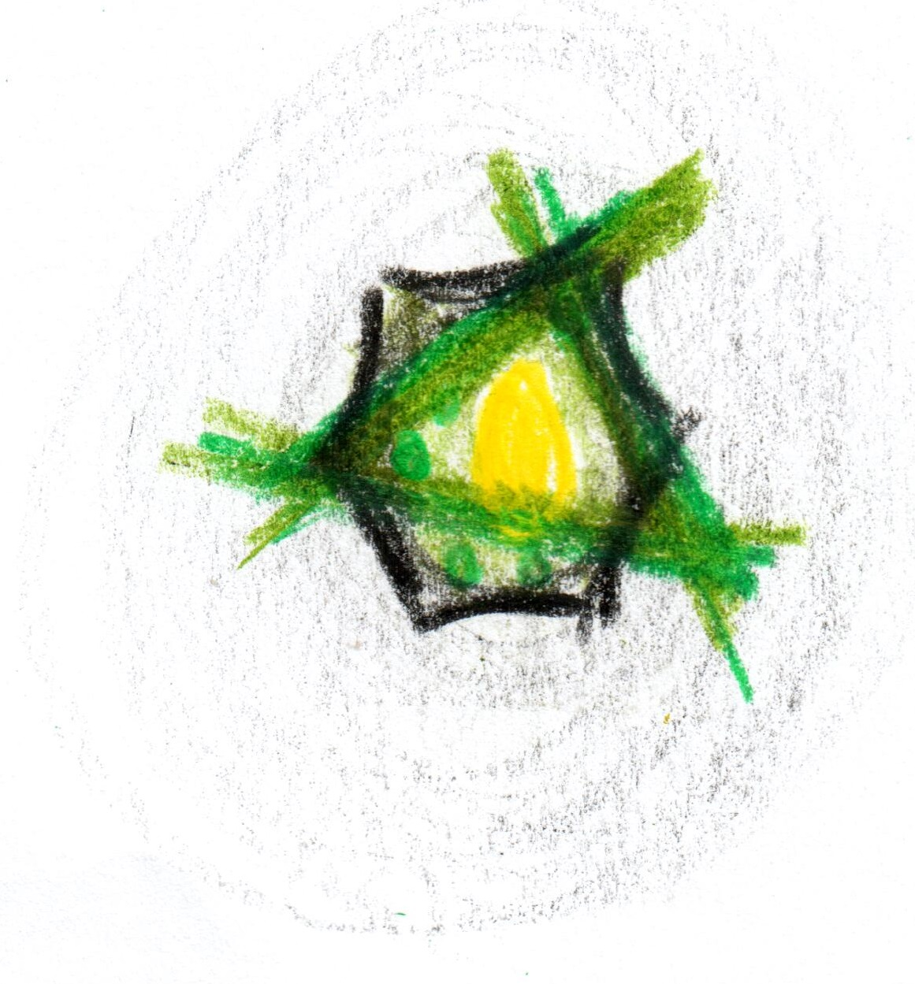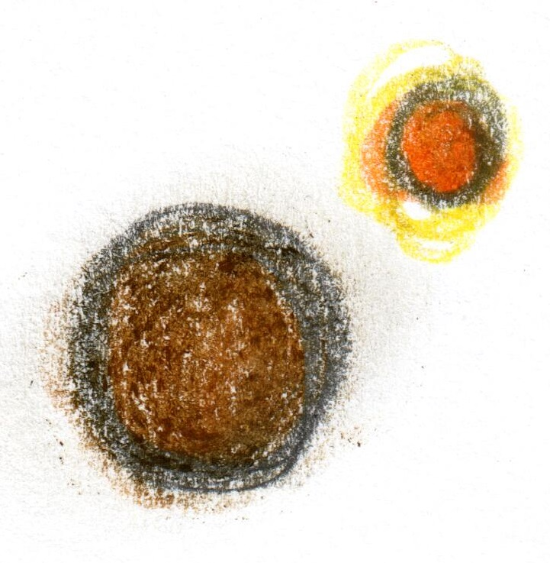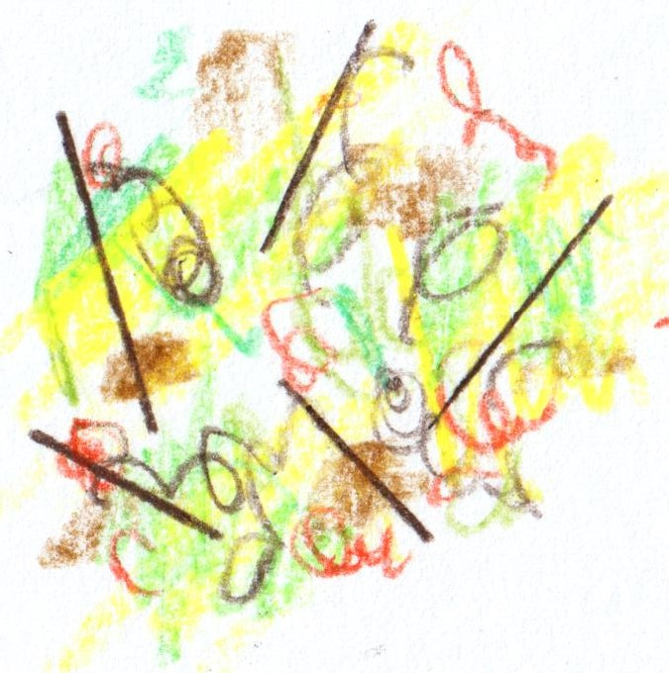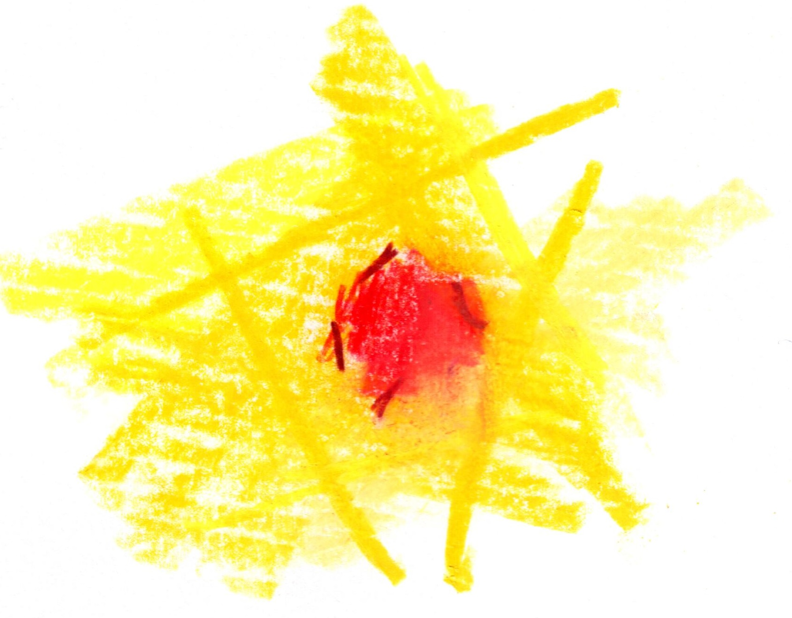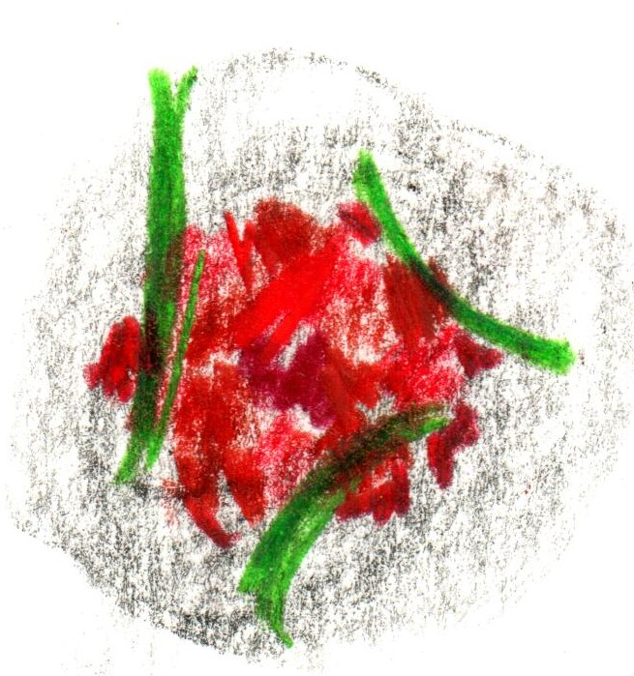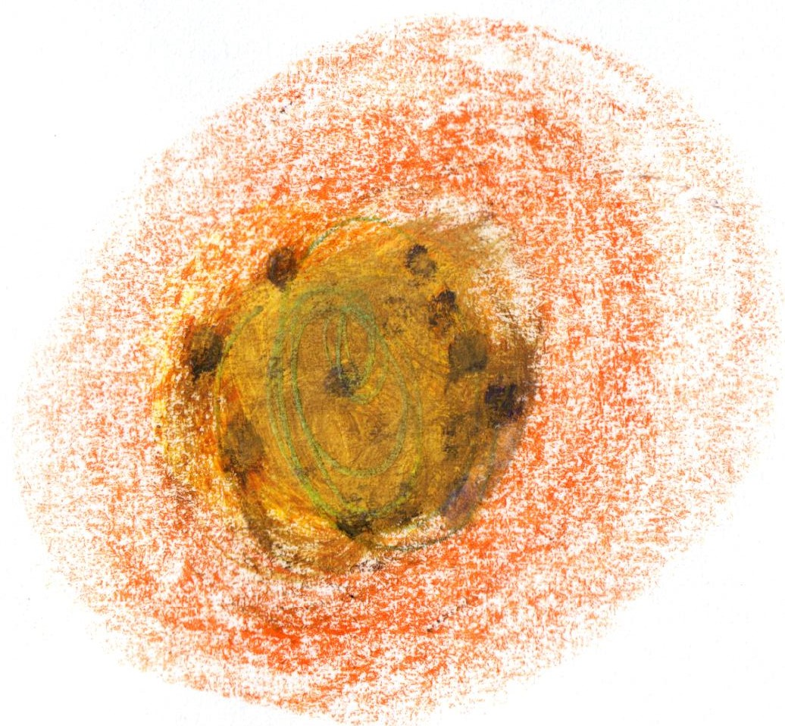

Scallop

tomato / rose

XO

St Brides Duck

x2

Squab from Anjou

mooli / pear

royale

Cornish Tuna

ponzu / fennel

Rhubarb

milk / hibiscus

Wild Garlic Quiche

charcoal / horseradish

Wild Turbot

mushroom / chicory

‘Conclusion’

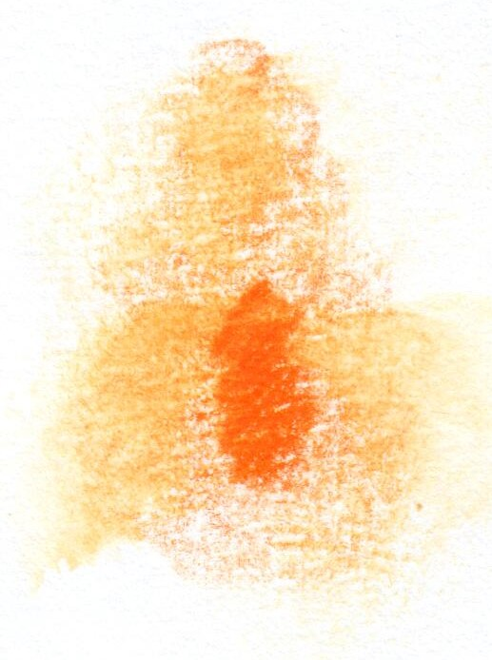

White Chocolate

yuzu / pine

‘Introduction’

‘The crossover’