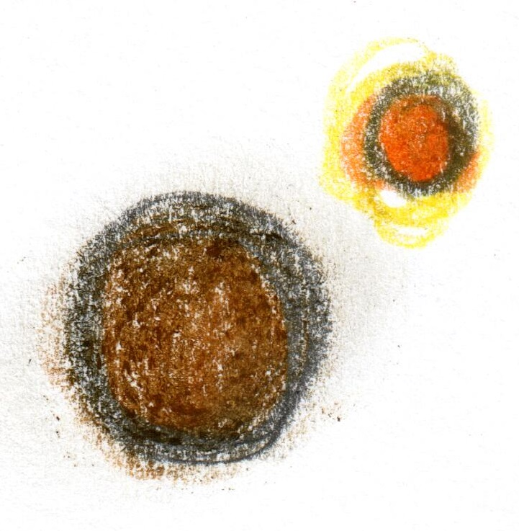

**Introduction**

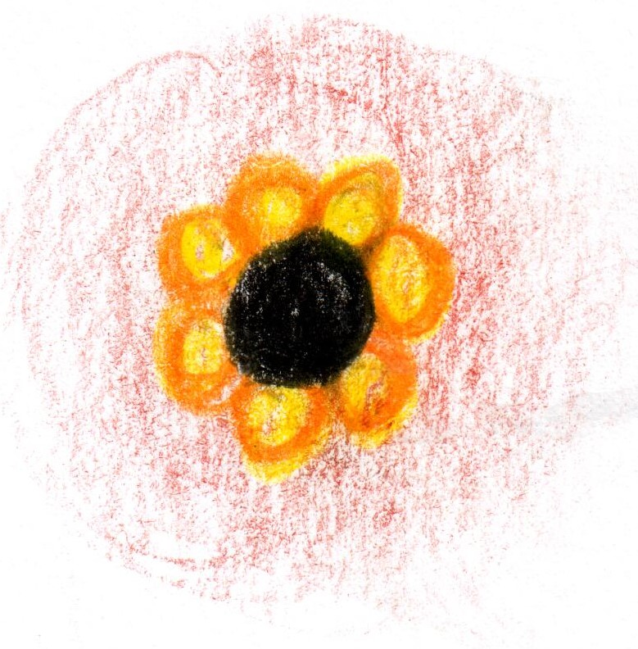

**Smoked Eel**

**apple / turnip**

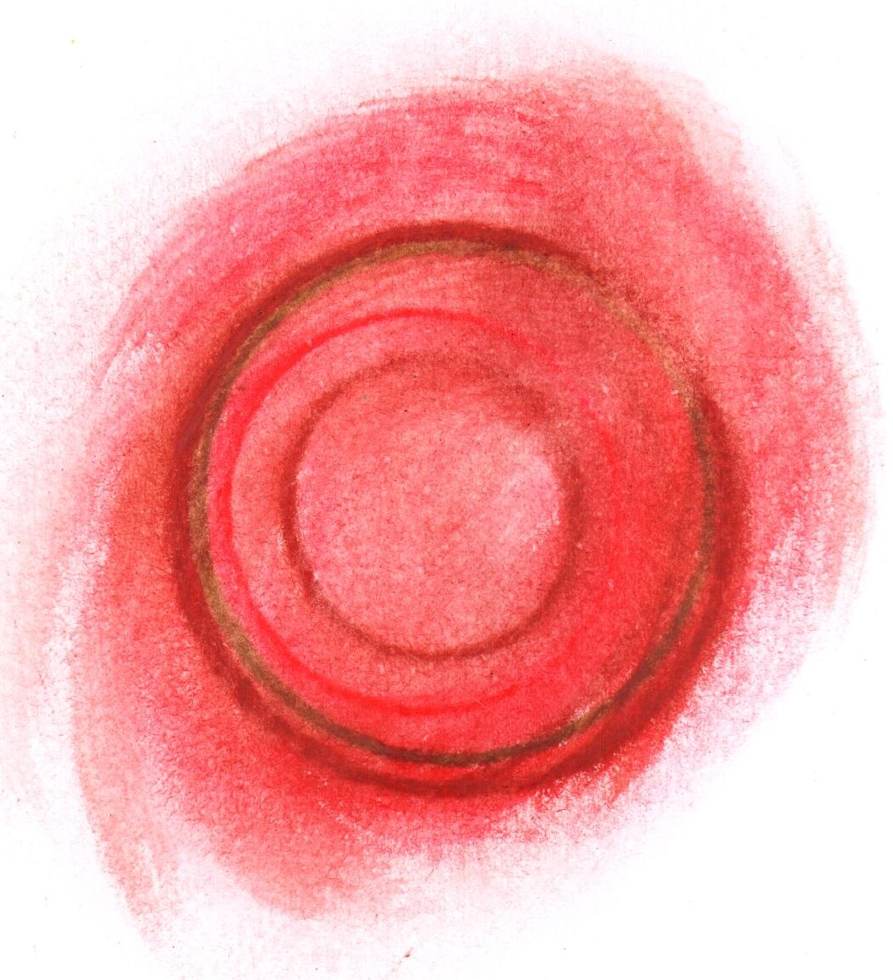

**Scallop**

**rose / tomato**

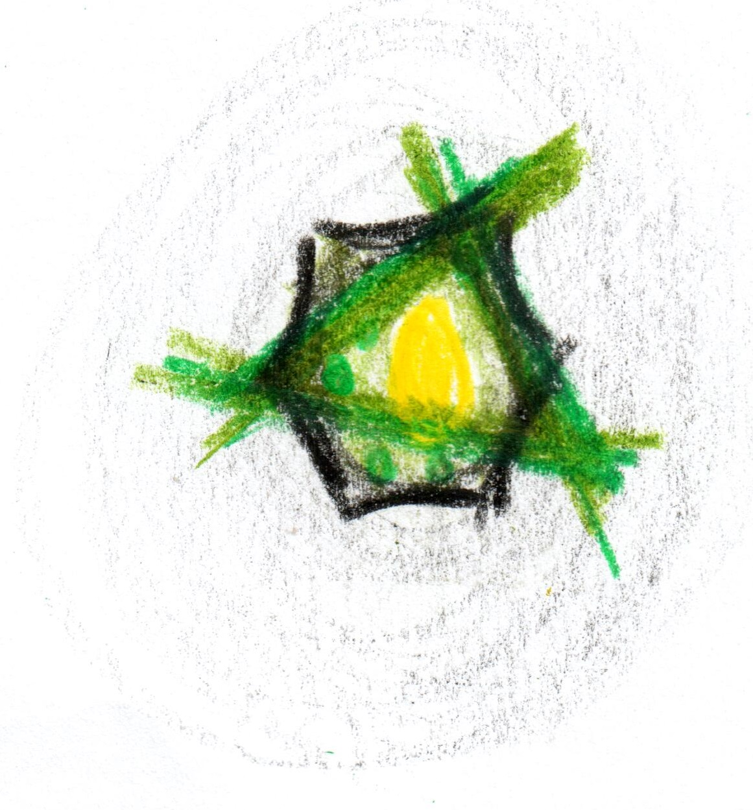

**Sea Leek**

**charcoal / horseradish**

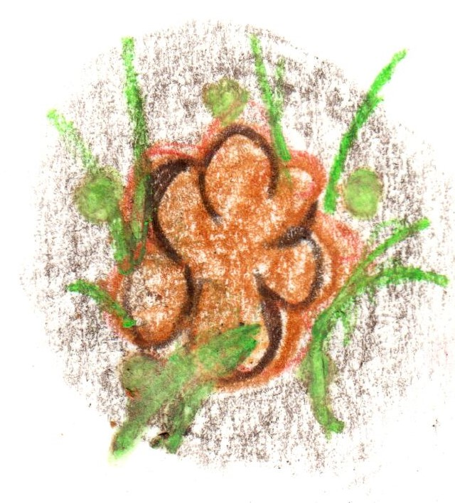

**Veal sweetbread**

**lentil / lime**

**indian spices**

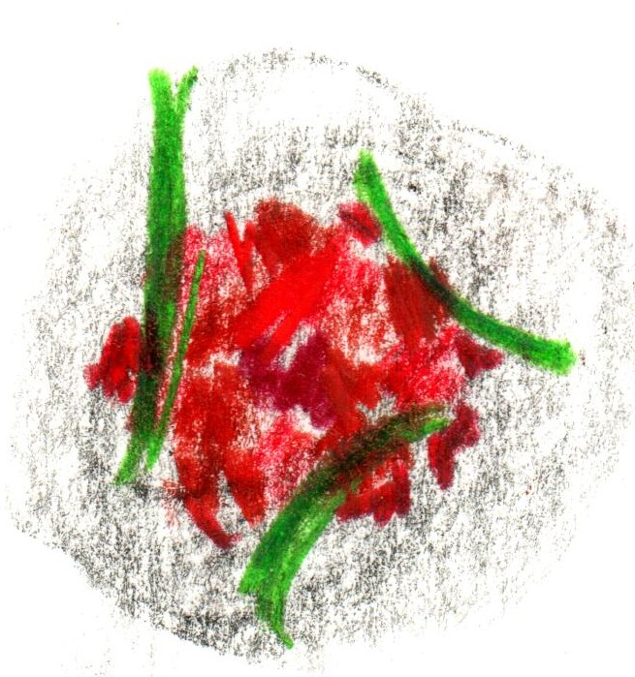

**Cornish Tuna**

**“tart-tare”**

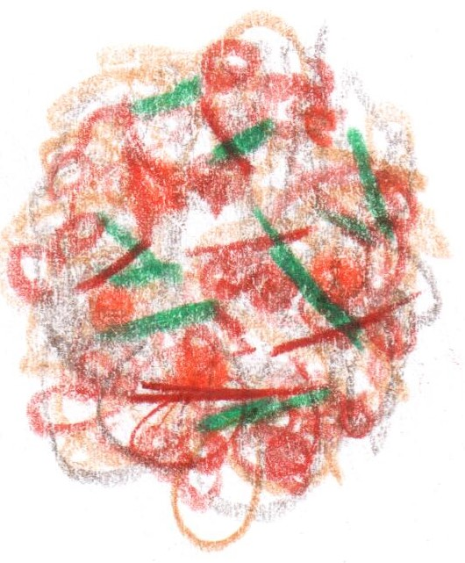

**Muesli**

**from the RSB Archive**

**Conclusion**

**‘Pelargonium’**

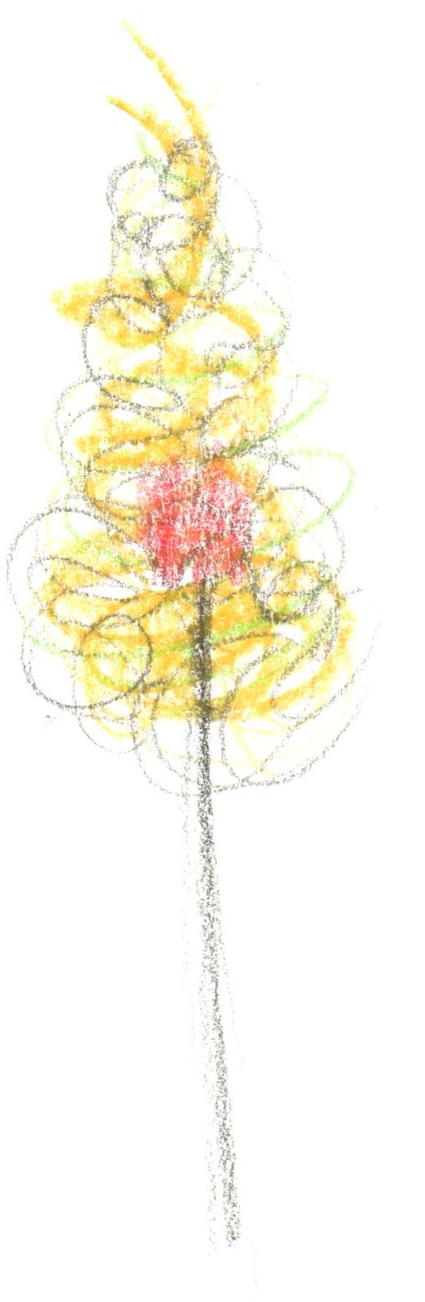

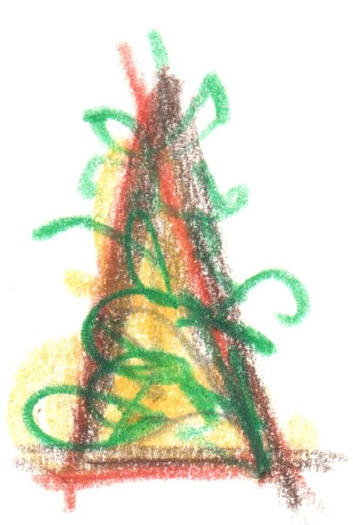

**From the Garden**

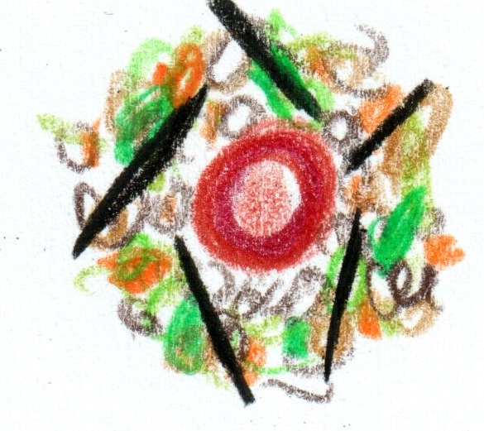

**St Brides Duck**

**x2**

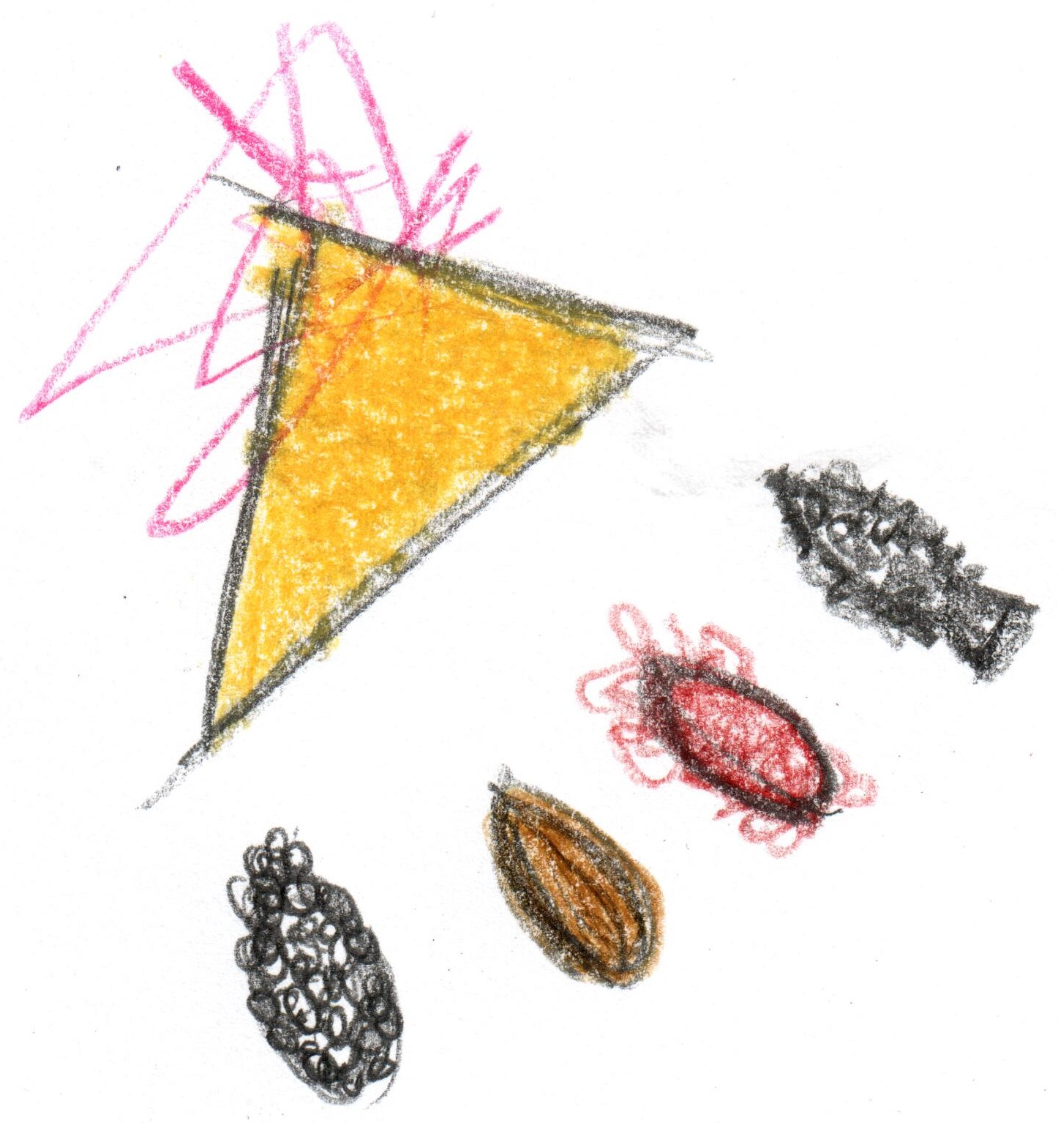

**Cornish Turbot**

**morel / chicory**

**caviar**

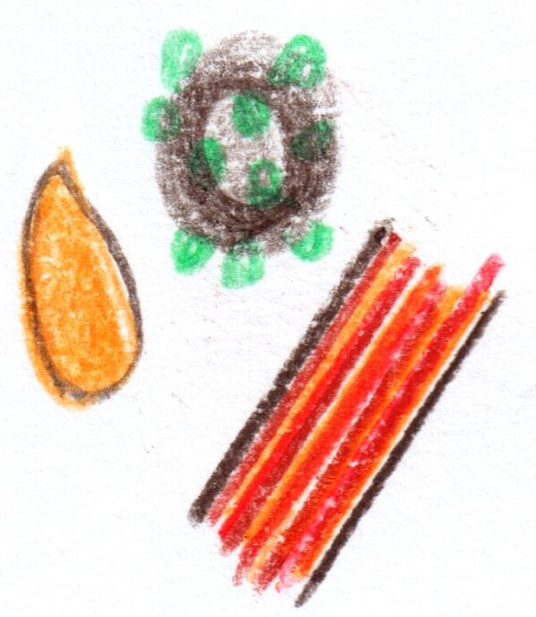

**Wagyu Beef**

**‘au poivre’**

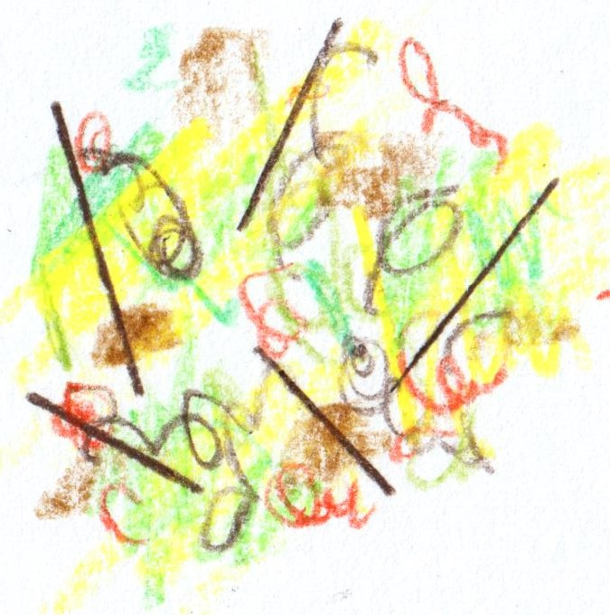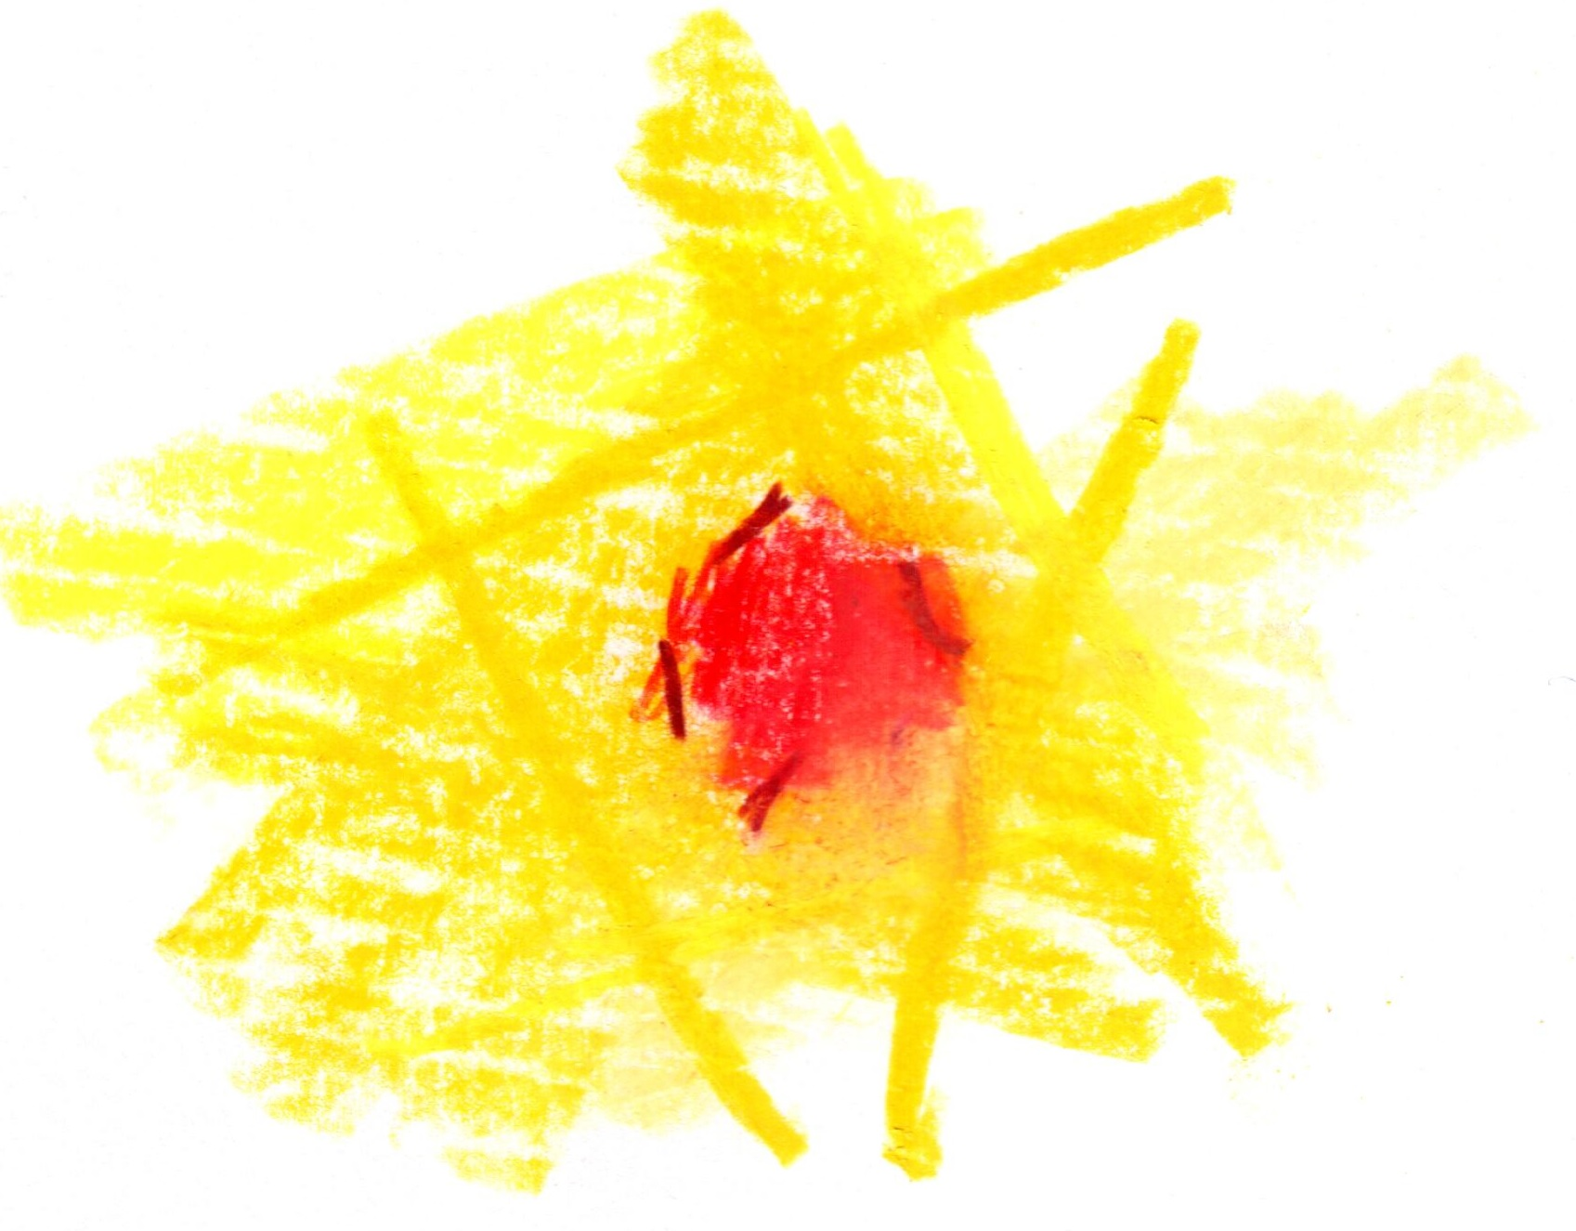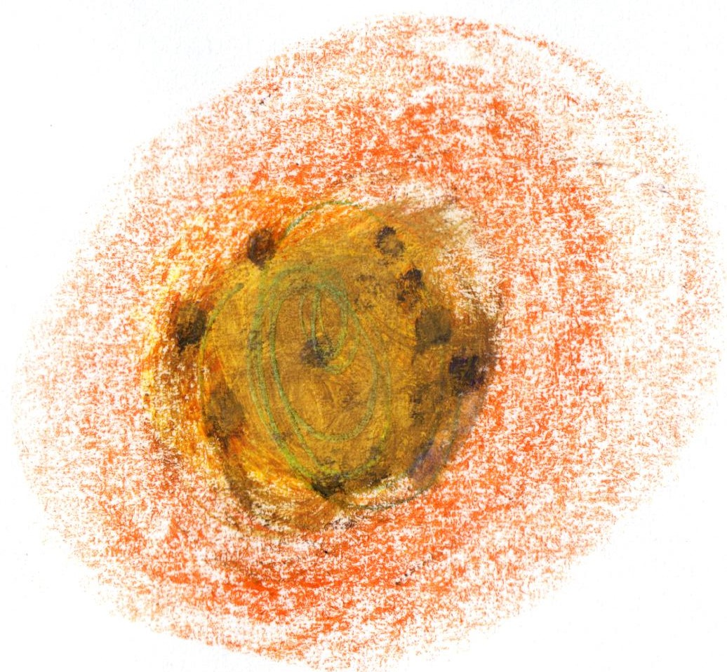

**White Chocolate**

**yuzu / pine**

**‘The crossover’**

**Rhubarb**

**hibiscus / milk**

**Conclusion**

**Fifteen Courses**

**£279**