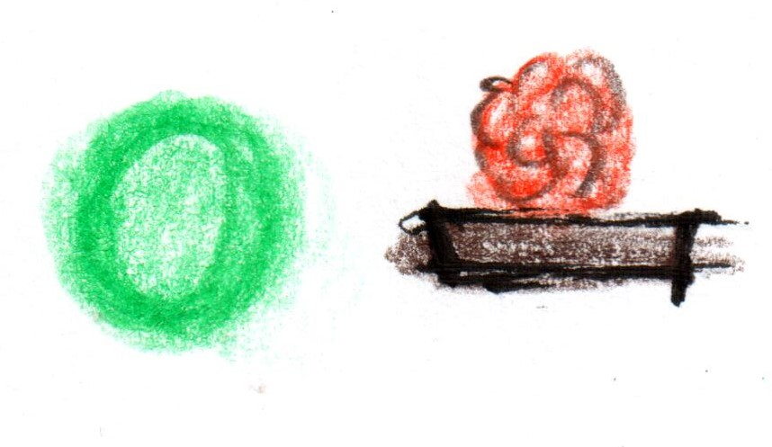

**Introduction**

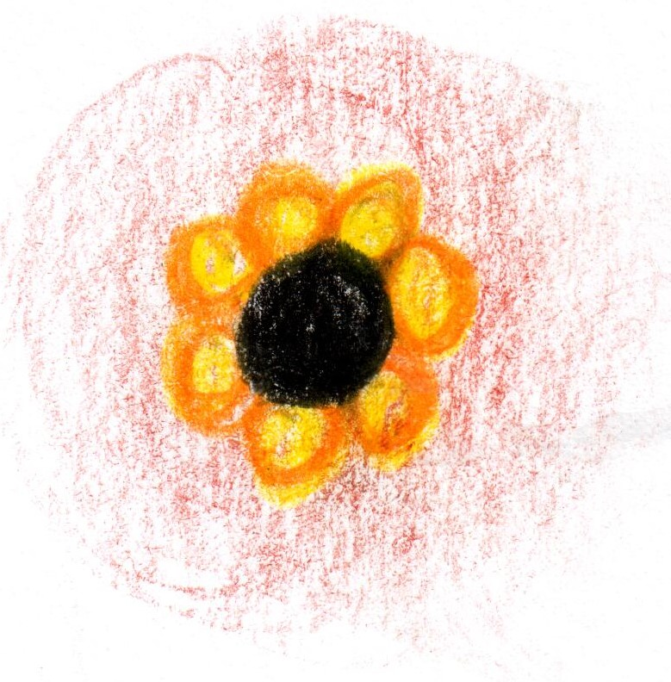

**Smoked Eel**

**apple / turnip**

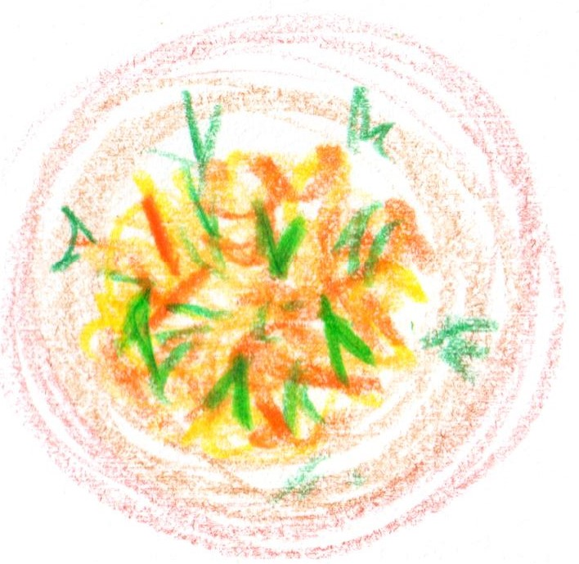

**Crab**

**peanut brittle**

**bisque**

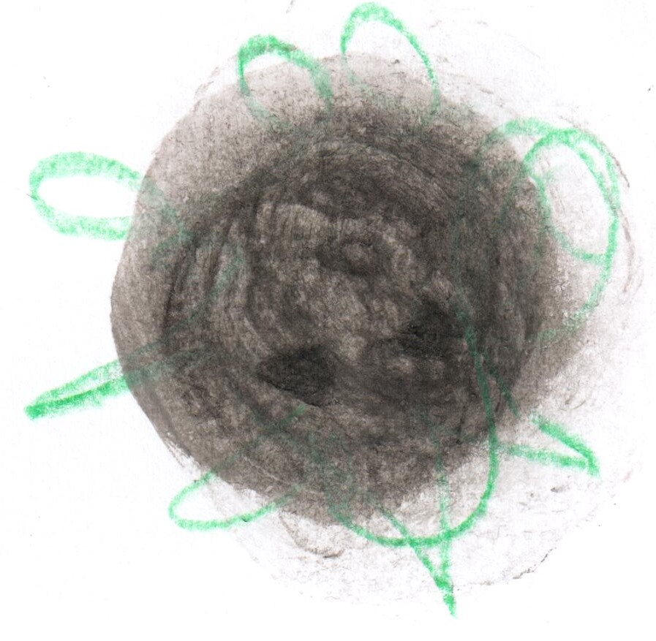

**From the Embers**

**potato / ash**

**caviar**

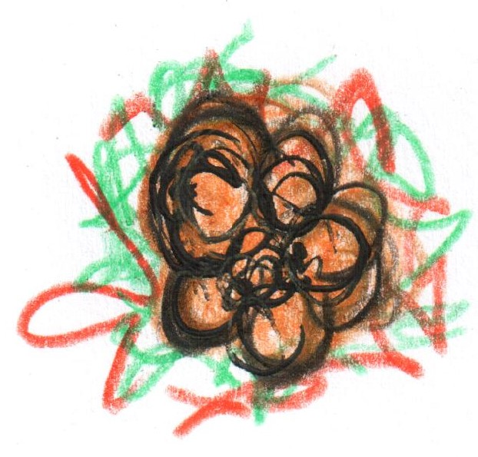

**Veal sweetbread**

**miso cabbage**

**sauce Robert**

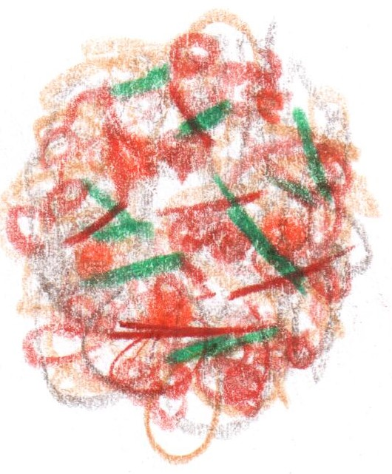

**Chicken Liver Muesli**

**from the RSB Archive**

**Confit Salmon**

**pike roe**

**dashi butter**

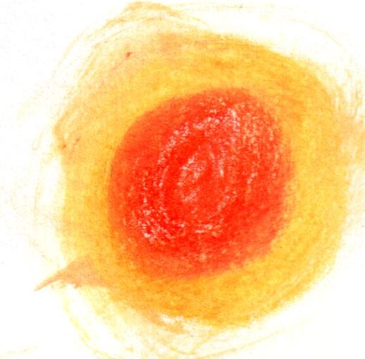

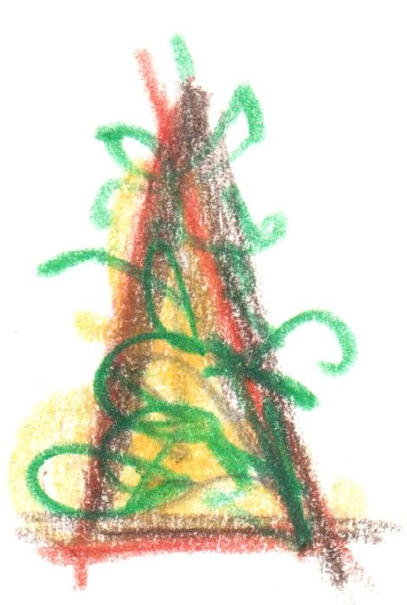

**From the Garden**

**Conclusion**

**‘Pelargonium’**

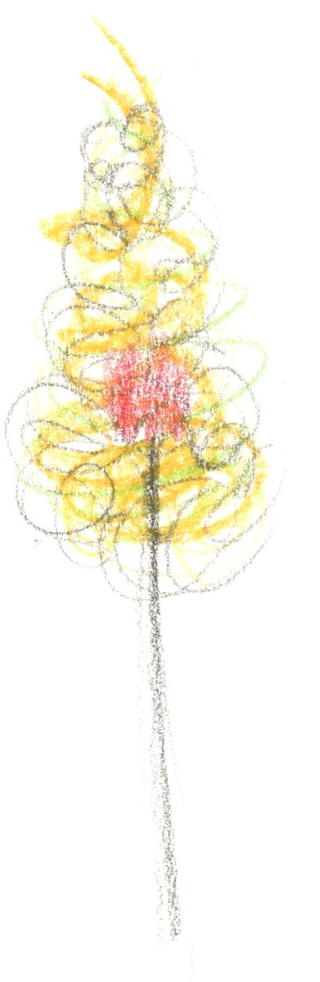

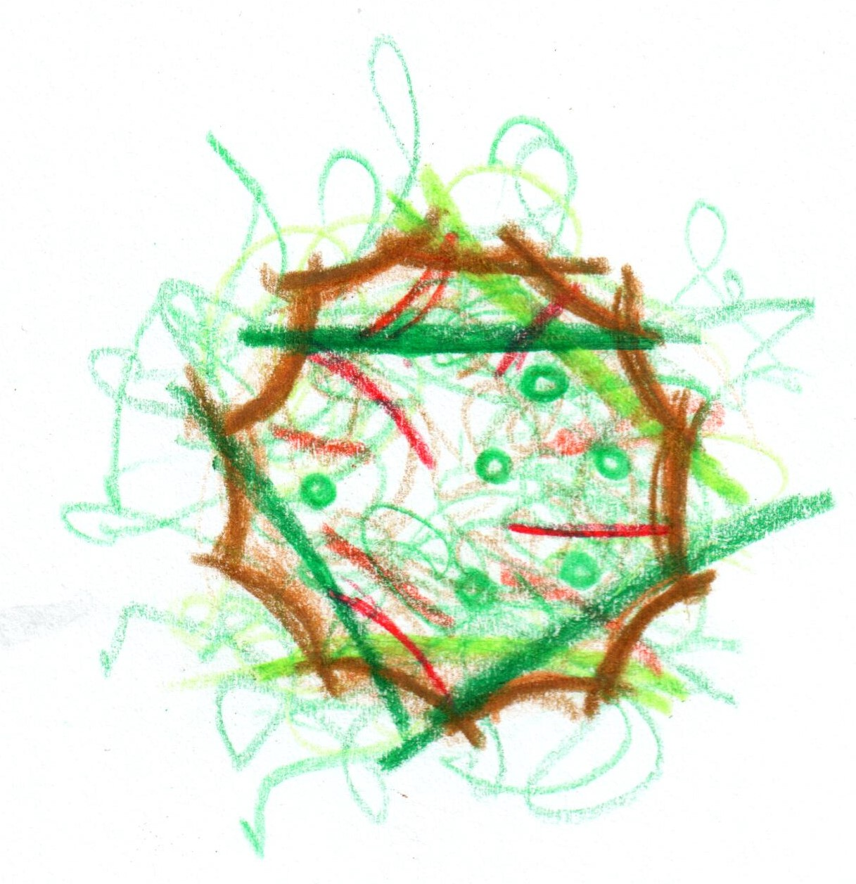

**Wild Mushroom Tart**

**pea viniagrette**

**seven year parmesan**

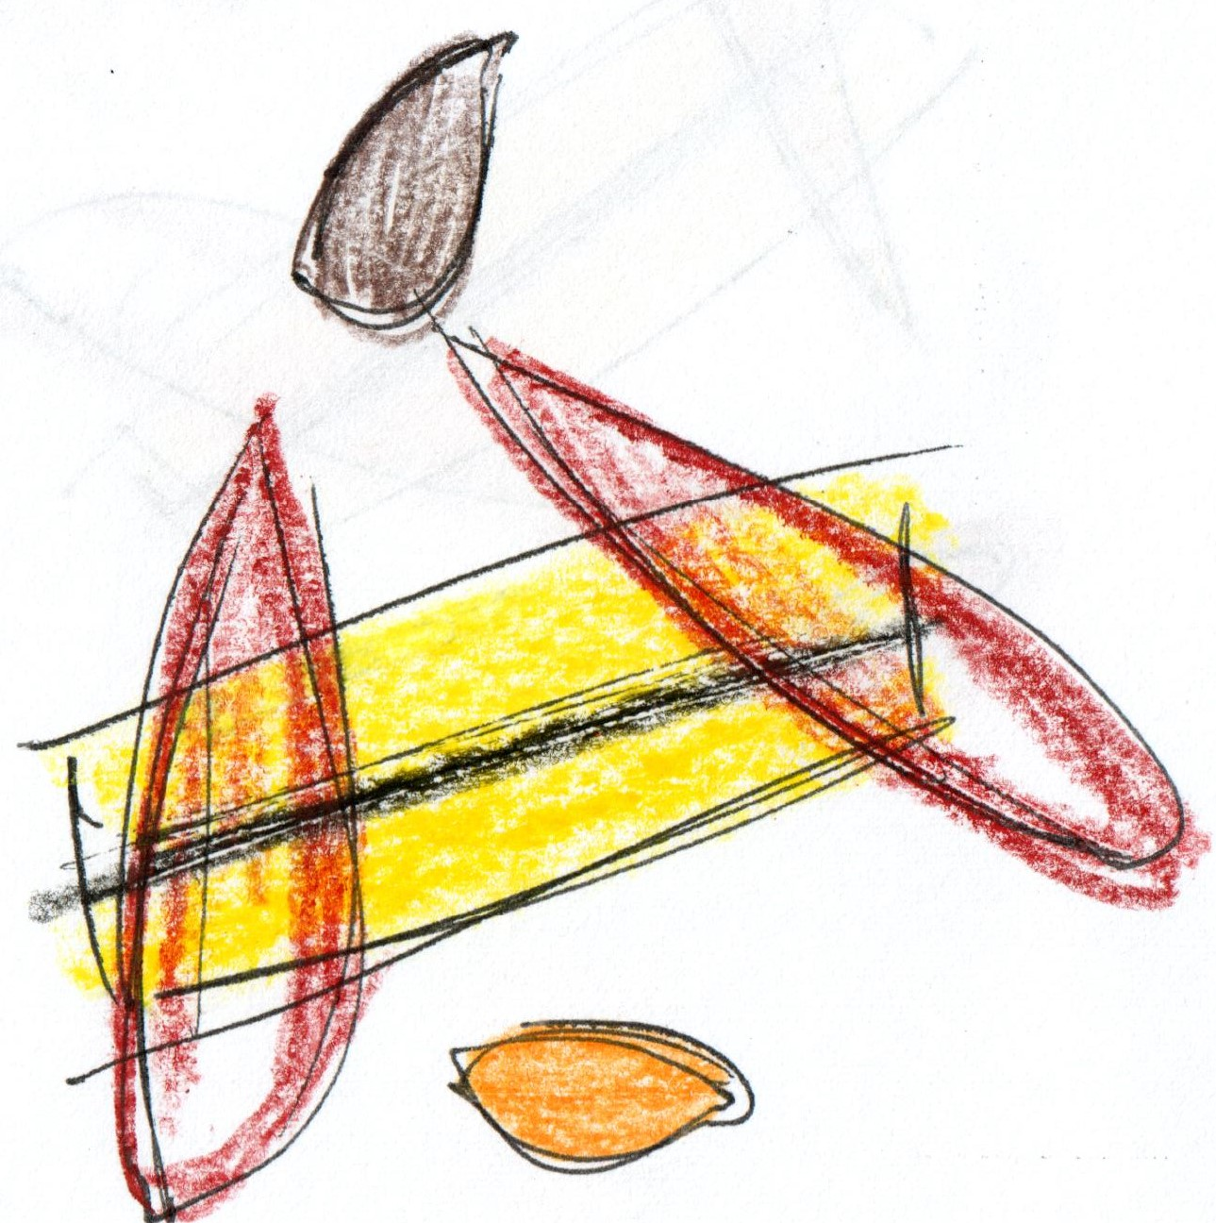

**Cornish Turbot**

**ceps / chicory**

**champagne**

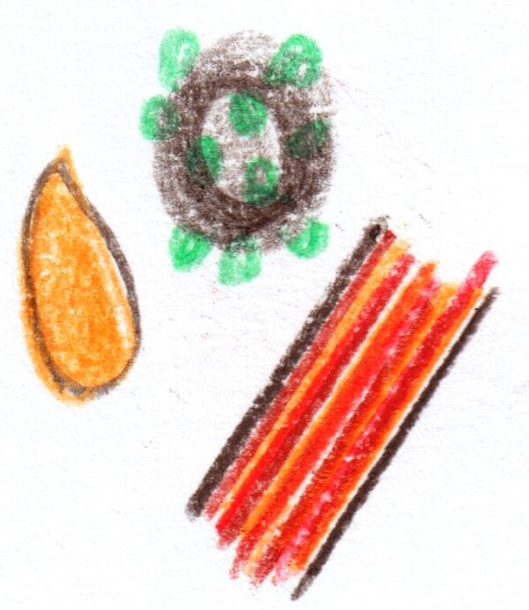

**Wagyu Beef**

**‘au poivre’**

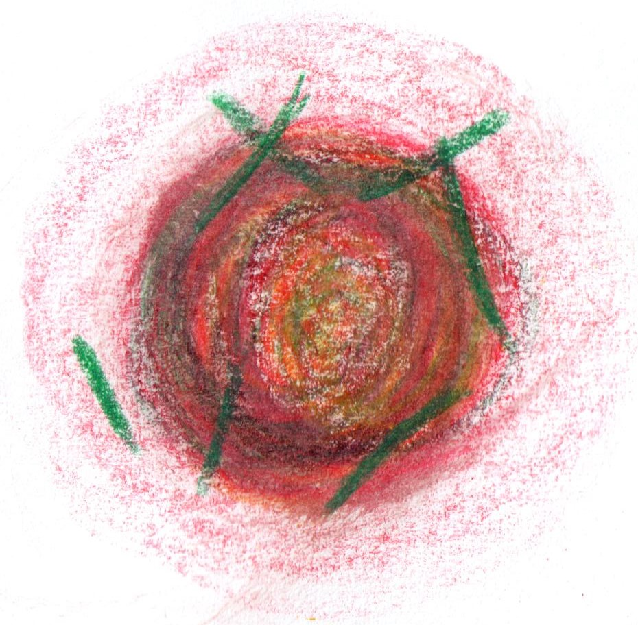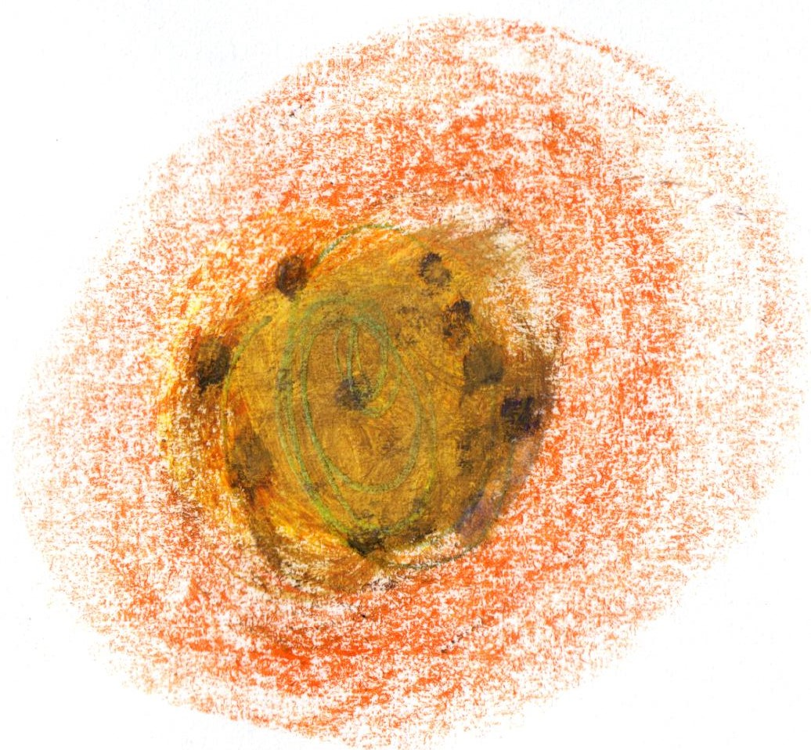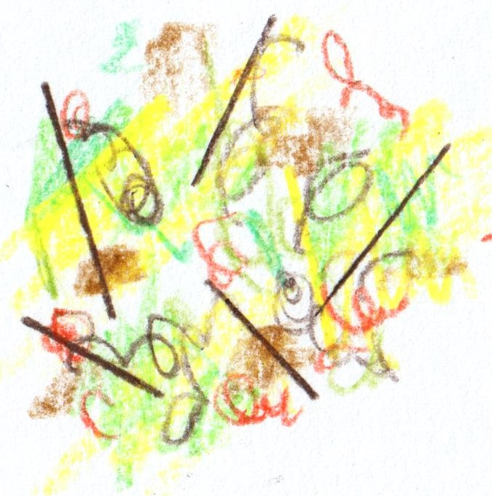

**Strawberry and Cream**

**black pepper**

**Conclusion**

**White Chocolate**

**pine / yuzu**

**Fifteen Courses**

**£279**

**‘The crossover’**